Universal Design explained in a diversity of ways
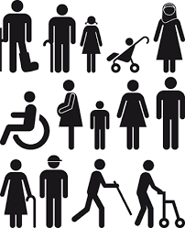
Wikipedia and universal design websites will have many of the standard explanations. But perhaps universal design is much more of a continuous conversation where many different words can be utilised in the discourse and discussions. In common use are "inclusive design", "design-for-all" and "design for the lifespan". But other words and terms might be:
Provocative design: doing things differently, challenging the status quo.
Fragile design: designs that require community agreement to hold them together.
Graphic courtesy DesignAustria
Careful or caring design: taking care to be inclusive in design thinking and processes.
Everyday design: designing more things to be ubiquitous, accepted and normal.
Thoughtful design: the opposite of thoughtless design where some people feel left out.
Empathetic design: similar to careful/caring design and thoughtful design, by putting yourself in the situation of others.
Looking to the future design: looking at how trends are developing and factoring this into designs.
Polite design: designs showing respect and consideration for other people
7 senses design: factoring all our senses into designs.
Collaborative design: in some cultures this is a significant part of the design process - without it the product, service or building won't be used.
Acceptable design: similar to collaborative design, but perhaps some compromises have to be made.
Disruptive design: changing the way things are done, challenging the status quo of designs, using environments or products in new ways.
Intergenerational design: family structures are diverse – recognising that not every family is a nuclear family whether at home or in the community.
Liveable design: being functional for everyone as well as looking good.
Universal usability: focusing on how people use things - used mostly in relation to mobile technology, particularly to include older people
Perhaps we should be using many different words in different situations to suit the understanding and perspective of different individuals?
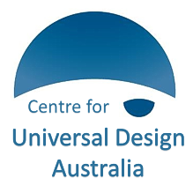
However, in keeping with the UN Convention of the Rights of Persons with Disability and the WHO Age Friendly Cities and Communities program, 'universal design' is an internationally accepted term that is understood as a concept for physical, social, economic and cultural inclusion.
http://universaldesignaustralia.net.au

