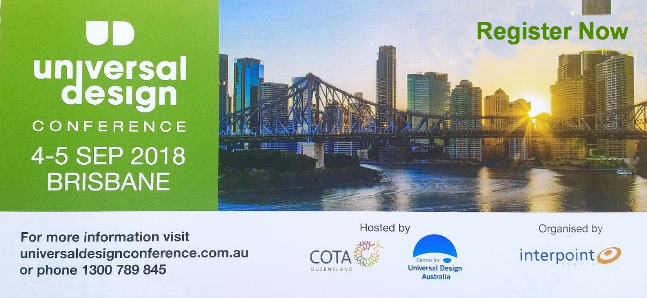

KEYNOTE SPEAKER PRESENTATION SUMMARIES
Universal Design and Person Centred Economics
Nicki Hutley
Thinking of housing as infrastructure has wide-reaching economic and social benefits and with an ageing population and policies that are designed to promote inclusion, it is time to take another look at how we approach the issue of secure and suitable housing. The accessible tourism movement has made some inroads into promoting the business benefits as a means of encouraging the tourism and destination sector to be more accessible and inclusive, but more can be done.

The Future of Transportation
What does the future of transportation mean for accessibility and inclusion?
Amy Child
Driverless vehicles have the potential to dramatically impact our future transport systems. Providing less mobile people and those who do not hold a driver license with access driverless vehicles is an exciting prospect for some. However what price will society pay for this ultimate freedom, and will this freedom ever be a reality?

Accessible Tourism: Everyone can benefit from an inclusive approach
Chris Veitch
Inclusive and accessible tourism, developed on the principles of universal design, ensures the maximum number of people, businesses and destinations benefit from travelling opportunities. Tourism is all about emotions: tourism operators want visitors to have amazing experiences - that ‘wow’ moment. By addressing accessibility it helps put customers at the heart of the visitor journey. This presentation will provide an update on inclusive tourism in Europe and UK, how to put customers at the heart of the visitor journey, and discuss tourism from a local development perspective.
As with all tourist destinations, the development process needs to be managed, as evidenced by the negative response of local communities to tourism in places such as Barcelona and Venice. Developing tourism along inclusive lines contributes to sustainability by improving the quality of life for local people who may otherwise encounter barriers and poor access to places and facilities. Policies and strategies at destination level need to be in place, but it also needs champions to promote the issues and solutions.
Inclusive and accessible development is not just a goal in itself, but a tool to help businesses and destinations achieve a range of business objectives, such as improving the quality of experience for everyone, and addressing issues of seasonality. There are six key elements of the customer journey – the value chain which needs to be accessible throughout to ensure a seamless journey: Information and Marketing (the push-pull factors); Booking processes; Travel to the destination; Getting around at the destination; and Recollection and Memory building that lead to recommendations and repeat visits.

Accessible Housing and the National Construction Code
Kieran O’Donnell
The Australian Building Codes Board’s (ABCB) is a Council of Australian Governments (COAG) standards writing body responsible for the development of the National Construction Code (NCC), which sets out the mandatory construction requirements for all buildings. The NCC is adopted by each State and Territory through its respective legislation. The NCC includes minimum building access requirements for people with a disability, however these requirements currently do not apply to housing. In 2017, the Building Ministers Forum, with the support of all COAG First Ministers, asked the ABCB to undertake a regulation impact assessment on the possible inclusion of accessibility standards for housing in the NCC. This presentation will provide an insight into the thinking behind the project and outline how the ABCB will deliver this significant and high priority project.

A journey in inclusive tourism: Finding and providing the right information
Nadia Feeney
The Australian Tourism Data Warehouse (ATDW) in partnership with Tourism Australia and all the State and Territory government tourism organisations, is the most comprehensive, central storage and multi-channel distribution network for tourism industry products and destination information, supporting over 40,000 listed products, 130,000 images across 11 product categories. This content is compiled in a nationally agreed format and electronically accessible by over 200 distribution partners including tourism operators, wholesalers, retailers and commercial distributors for use in their consumer facing websites, mobile applications and booking systems.
ATDW in conjunction with Local Government NSW (LGNSW) and Destination New South Wales (DNSW) have recently completed a project to enhance and boost the level and type of accessibility content which is available to consumers looking to book an inclusive travel holiday or experience through this vast network. Hence making it easier for consumers with specific needs be they wheelchair access, mobility support, allergy, vision or audio services to search for and locate Australian tourism experiences to suit their needs. Research conducted by the University of NSW and an extensive consultation process, as part of the project, guided the development of the new questions and dataset. This dataset was then built into the ATDW-Online platform and database and has become a mandatory field for all business and event listings to complete.
This presentation will showcase the new dataset, the platform interface changes and look at the response and outcomes of the collection of this accessible content. Where possible, a case study of the implementation of the data to consumers will also be demonstrated.

