Annual Report 2017-2018

Chairperson’s Report

Background
Centre for Universal Design Australia Ltd was founded 11 January 2016 with three directors, Jane Bringolf, Sally Coddington and Nicholas Loder. Pro bono assistance with setting up the organisation as a company limited by guarantee (a not-for-profit entity) was provided by Stuart Cameron of KS Black & Co.
Subsequent to the setting up of the organisation, a call for expressions of interest for five remaining director positions was made in July 2016. The closing date for submissions was set after the staging of the 2nd Australian Universal Design Conference in late August. Five additional directors were appointed: two from New South Wales, two from Victoria and one from Queensland.
Membership for individuals was offered to the public and all states are represented in our membership base. CUDA became a registered charity in January 2018.

Activities
Presentations: Housing Forum held by Australian Network for Universal Housing Design and RI Australia in Sydney; Housing Design seminar held by North Sydney Council; Association of Consultants in Access Australia conference; Universal Design Forum in Adelaide; AHURI National Housing Conference; and ICTH Conference in Barcelona.
Workshops: Presented a capacity building workshop for residents of the new Waterloo redevelopment project.
Education: CUDA developed its first online learning course, Introduction to Universal Design which covers the seven classic principles, the eight goals, stereotyping and diversity. This course will continue to be free. There are plans to develop modules that build on this entry level course. At the end of June 2018 there were 171 students with 78 completing the course.
Other activities:
Directors participated in various community consultations, committees, roundtables and specialist workshops. These included the Greater Sydney Commission, Health Built Environment Working Group, Local Government NSW, NSW Veterans Affairs Anzac Memorial, City of Sydney Inclusion Panel, Sydney Modern Art Gallery, Sydney Olympic Park
Authority Access Committee, the development of guidelines for inclusive playspaces for NSW Planning, National Disability Strategy and Indigenous People with Disability workshop, and MOD.A working group on quality standards for home modifications. Began negotiations with Lendlease Australia to jointly hold short seminar events. Also assisted various academics with their research projects, and Parramatta City Council with their inclusion project.
Written contributions included a short paper to the Commonwealth Science Council: Council of Learned Academies on artificial intelligence, and an article for Inner Sydney Voice; and an article for Access Insight (the newsletter for access consultants).
Preparation for the 3rd Australian Universal Design Conference in Brisbane was an ongoing major activity for the organisation this year.
Website statistics for July 2017 to June 2018
CUDA’s website is an important part of operations as a repository of information covering research papers, news items, and opinion pieces on the topic of inclusive practice and universal design. The statistics show that over the last year the number of website views rose by almost 50% from the previous year: 27,400 to 39,300. The chart below shows the monthly trends, which is now reaching between 3000 – 4000 views per month. The number of newsletter subscribers at the end of June was 360, a net gain of 120. This was achieved without advertising or promotion.
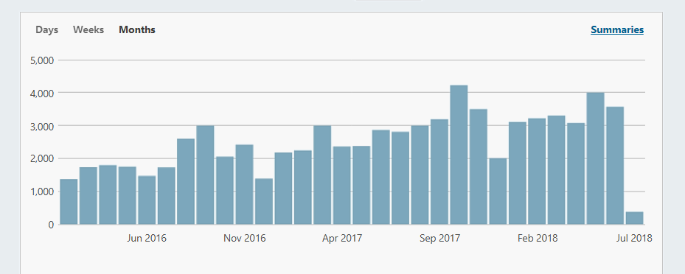

The number of visitors to the site remains steady at approximately two views per visit. There are two possible explanations for this. One is that visitors start at the Home Page and can find the information they seek quickly and easily and click external links. The other is that they have little interest and leave the site. The chart below shows the number of visitors in relation to page views. The dark shade is visitors and the light shade is views.

An analysis of the most viewed posts revealed that no topic in particular was more popular than another. However, the 8 Goals of Universal Design and the 7 Principles of Universal Design were in the top ten posts for the year.
Linked In (under name Jane Bringolf) proved to be more popular for CUDA posts than Facebook, particularly after Facebook received negative publicity this year.

Looking to the Future
We will be offering Lifetime Membership for individuals who want to sign up as a member and not have the worry to renew each year. We will also be offering Corporate Memberships for smaller organisations and businesses. All members will be eligible to use the CUDA logo on condition that it is used responsibly. To help with finances we will offer one space per newsletter for paid advertising provided such advertising is related to our quest for universal design and inclusive practice.

Dr Jane Bringolf
Chair, Centre for Universal Design Australia Ltd

Board of Directors 2016-2017

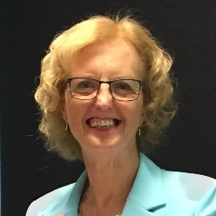
Jane Bringolf: BSSc, MBA, PhD, Churchill Fellow (Chair).
Jane has worked in community services for more than thirty years and has a broad understanding of the sector, particularly ageing and disability. A recipient of a Churchill Fellowship in 2004, Jane travelled overseas to investigate organisations pursuing universal design, accessible environments and assistive technology. She later completed a PhD in urban studies focusing on universal design in housing. Jane gained her grounding in universal design as Executive Director with the Independent Living Centre NSW, and put this knowledge to use more recently as Liveable Communities Project Manager with Council on the Ageing NSW (COTA NSW).
Jane attended 12 out of 12 meetings.
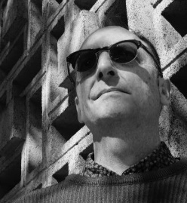
Nicholas Loder: B.Arch, M.BuiltEnv, Grad Dip PSM (Deputy Chair).
Nicholas is Senior Project Officer, NSW Land and Housing Corporation, Family and Community Services. Since 2003 he has provided design policy advice for multi-unit medium density residential and major refurbishments projects for LAHC, especially on accessibility and universal design. Previously he worked in various architectural firms working on a range of projects. Nicholas sits on several committees including the NSW Chapter Australasian Housing Institute. He is also a volunteer tour guide for AAA and Sydney Living Museum’s Sydney Open, a member of DOCOMOMO NSW, and of the Society for Architecture and Urban Design Incorporated (SFAUDI).
Nicholas attended 11 out of 12 meetings.

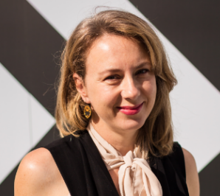
Phillippa Carnemolla: BIndDes, MDes, PhD
Phillippa is a Research Fellow and Industrial Designer with extensive experience in design practice, research and education. Phillippa has a Bachelor of Industrial Design and Masters of Design (Research) from University of Technology, Sydney, and a PhD from UNSW, Sydney. Her PhD, completed in 2015, investigated the impact of home modifications on caregiving and health-related quality of life. Phillippa’s research interests are focused on human-centred and inclusive design of housing, urban infrastructure and new technologies for older people and people living with disability.
Phillippa attended 7 out of 12 meetings
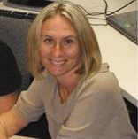Lisa Stafford: PhD
Lisa is a social planner, social scientist, and a Lecturer at QUT in the School of Public Health and Social Work. She has 17 years of experience in the field of disability and inclusion with a specific focus on the social-spatial needs of children, young people and their families. Part of this work included the development and management of All Abilities Playground Projects across Queensland between State and Local Governments. Previously Lisa worked in practitioner, management and director roles in government and non-government organisations. As a researcher, Lisa specialises in person-environment studies and applied research in Inclusive Communities and Social-Spatial Justice. Specific areas of interest: universal design neighbourhoods, mobility, inclusive play spaces, and regional area perspectives.
Lisa attended 8 out of 12 meetings

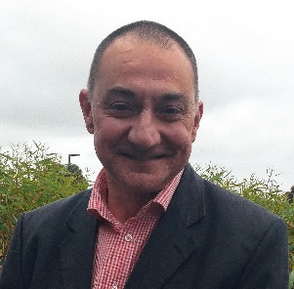
Phillip Taylor: BSc (Hons), MSc, PhD
Philip has almost 30 years of experience as an expert researcher, policy writer and governmental and NGO advisor on workforce ageing. His interests include individual orientations to work and retirement, employer behaviour towards older workers and international developments in public policy aimed at extending working life. He holds professorial positions with the University of Melbourne and Federation University Australia and is a research fellow in think tank Per Capita's Centre for Applied Policy for Positive Ageing (CAPPA).
Philip attended 9 out of 12 meetings
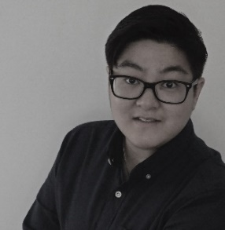
Queenie Tran: BArch, MArch
Queenie has developed extensive experience in architecture and access consulting. She has provided expert guidance in accessibility with relation to residential, health, commercial and industrial projects. In 2010, Queenie established ‘Wall to Wall Design + Consulting’ as an architectural design and consultancy practice with a commitment in developing functional and aesthetic solutions, inclusive of all people and their needs. More recently, Queenie has been working with the NFP sector to increase the supply and quality of housing for people with disability, including Summer Housing as the Housing Projects Manager.
Queenie attended 10 out of 12 meetings

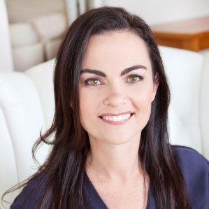
Sally Coddington: MBA, CPM
Sally has a background in business and marketing, and through her consultancy, Curb Cut Effect advises businesses about commercial solutions to empower people with disability. She has held leadership positions in the not-for-profit sector, including the Hunter Business Chamber, Hunter Life Education, Becoming Healthy Australia, and is currently a member of the NSW Disability Council. She has lectured at the University of Newcastle Business School, and has worked in the finance sector in Australia and overseas.
Sally resigned in February 2018 and attended 4 out of 5 meetings

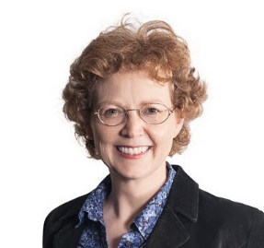
Penny Galbraith: FAIB, FRICS
Penny is a built environment professional with a career long interest in accessibility and universal design. Consultancy roles have covered a range of clients and built environment forms including: Underwater World, State Library of Queensland, Princes Pier, master planning senior living villages, NW Rail Link, and more recently helping the City for Greater Geelong determine ‘what accessible looks like’. Strategy, research and futures thinking underpin Penny’s work.

Penny was appointed in September 2017 attended 9 out of 10 meetings

Centre for Universal Design Australia Ltd
Income and Expenditure Statement
for year ended 30 June 2018

 | 2016-2017 | 2017-2018
INCOME
Bal b/fwd | 402.98 | 904.19
Membership fees | 1450.30 | 2225.63
Donations | 650.00 | 559.18
Other Income -
Workshop fees | 800.00 | 350.00
MEA presentation |  | 450.00
Anzac community cons |  | 210.00
Bank Interest | 5.79 | 9.91
TOTAL INCOME | $3309.07 | $4708.91
EXPENDITURE
Meeting expense | 130.60 | 510.45
ASIC fees | 1176.00 | 1201.00
AGM room hire |  | 253.00
Insurances | 1098.28 | 1098.28
TOTAL EXPENSES | $2404.88 | $3062.73
Income less Expenditure | $904.19 | $1646.18

Cash at bank as at 30 June 2018 was $1646.18.
Centre for Universal Design Australia Ltd was registered for GST from 1 February 2018. GST reporting resulted in a nil balance between GST paid and GST refunded.

