Annual Report 2016-2017

Chairperson’s Report

Background
Centre for Universal Design Australia Ltd was founded 11 January 2016 with three directors, Jane Bringolf, Sally Coddington and Nicholas Loder. Pro bono assistance with setting up the organisation as a company limited by guarantee (a not-for-profit entity) was provided by Stuart Cameron of KS Black & Co.
Subsequent to the setting up of the organisation, a call for expressions of interest for five remaining director positions was made in July 2016. The closing date for submissions was set after the staging of the 2nd Australian Universal Design Conference in late August. Five additional directors were appointed: two from New South Wales, two from Victoria and one from Queensland.
Membership for individuals was offered to the public and resulted in 62 members by the end of June 2017. All states are represented in our membership base with the majority coming from New South Wales and Victoria.

Activities
2nd Australian Universal Design Conference
The key event for this reporting period was the 2nd Australian Universal Design Conference, which was held once again in Sydney with the sponsorship of City of Sydney and NSW Family and Community Services. Interpoint Events also sponsored with in kind contributions to the conference organising, with COTA NSW assisting. The variety of speakers over a range of topics made for a very interesting program. Planning is underway for the next conference to be held 4-5 September 2018 in Brisbane.
Presentations:
Meetings and Events National Conference: Inclusive meetings and events
Australasia-Pacific Post-Polio Conference: Universal Design: Beyond the Access Codes
Universal Design Conference in Auckland: Panel member
International Conference on Transport and Health, Barcelona: Poster presentation: Silver, Goldilocks and Platinum – Finding the Sweet Spot for Health and Housing
Workshops:
Tweed Shire Council staff workshop: Universal Design: Beyond the Access Codes
Master Class on for Stockland on behalf of Touched by Olivia Foundation: Inclusive Design Principles for Retail Play Spaces
Sunshine Coast Regional Council Inclusive Tourism and Community Planning Forum: Planning and Designing for Diversity with Universal Design
Auburn Council Thinkability Forum: Advocacy around Universal Design Principles and CALD People with Disability
Other activities:
Submission to Senate Standing Committee on the National Disability Strategy 2010-2020 (submission number 26).
CUDA was represented at an accessible tourism workshop run by Local Government NSW, and a workshop by Transport for NSW on Transport Futures.
Two Directors participated in research for Deakin University’s universal design project.

Website and social media
Activity on the website continued throughout the year and at the end of June the website had received more than 45,000 views since its inception in May 2015. Website views increased this reporting period from 14,320 to 28,228 – almost double compared with the same period last year. Subscribers to the weekly Latest Posts increased from 151 to 234. The website was set up to accept credit card payments as well as PayPal.
Subscribers to the Latest Posts (newsletter) numbered 243 and at the end of June 2017 there were 660 current posts on topics across the built environment, product design, human rights, ICT, travel and tourism, and UD in Learning. Social media attention increased over this time using Facebook, Linked In and to a lesser degree, Twitter, to promote the latest posts on the website. Social media is also good for additional material that does not meet with the clearinghouse style of the website, but can also be informative about disability issues and inclusion.
Dr Jane Bringolf
Chair, Centre for Universal Design Australia Ltd
14 September 2017
Board of Directors 2016-2017

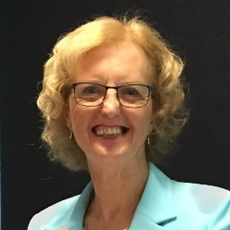
Jane Bringolf: BSSc, MBA, PhD, Churchill Fellow (Chair).
Jane has worked in community services for more than thirty years and has a broad understanding of the sector, particularly ageing and disability. A recipient of a Churchill Fellowship in 2004, Jane travelled overseas to investigate organisations pursuing universal design, accessible environments and assistive technology. She later completed a PhD in urban studies focusing on universal design in housing. Jane gained her grounding in universal design as Executive Director with the Independent Living Centre NSW, and put this knowledge to use more recently as Liveable Communities Project Manager with Council on the Ageing NSW (COTA NSW).
Jane attended 7 out of 8 meetings.
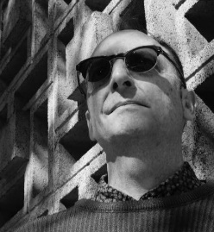
Nicholas Loder: B.Arch, M.BuiltEnv, Grad Dip PSM (Deputy Chair).
Nicholas is Senior Project Officer, NSW Land and Housing Corporation, Family and Community Services. Since 2003 he has provided design policy advice for multi-unit medium density residential and major refurbishments projects for LAHC, especially on accessibility and universal design. Previously he worked in various architectural firms working on a range of projects. Nicholas sits on several committees including the NSW Chapter Australasian Housing Institute. He is also a volunteer tour guide for AAA and Sydney Living Museum’s Sydney Open, a member of DOCOMOMO NSW, and of the Society for Architecture and Urban Design Incorporated (SFAUDI).
Nicholas attended 8 out of 8 meetings.

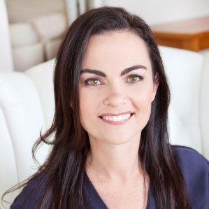
Sally Coddington: MBA, CPM
Sally has a background in business and marketing, and through her consultancy, Curb Cut Effect advises businesses about commercial solutions to empower people with disability. She has held leadership positions in the not-for-profit sector, including the Hunter Business Chamber, Hunter Life Education, Becoming Healthy Australia, and is currently a member of the NSW Disability Council. She has lectured at the University of Newcastle Business School, and has worked in the finance sector in Australia and overseas.
Sally attended 7 out of 8 meetings

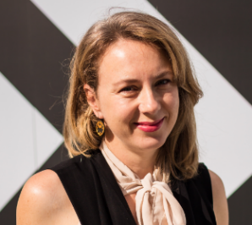
Phillippa Carnemolla: BIndDes, MDes, PhD
Phillippa is a Research Fellow and Industrial Designer with extensive experience in design practice, research and education. Phillippa has a Bachelor of Industrial Design and Masters of Design (Research) from University of Technology, Sydney, and a PhD from UNSW, Sydney. Her PhD, completed in 2015, investigated the impact of home modifications on caregiving and health-related quality of life. Phillippa’s research interests are focused on human-centred and inclusive design of housing, urban infrastructure and new technologies for older people and people living with disability.
Phillippa attended 4 out of 5 meetings
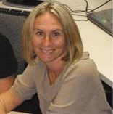
Lisa Stafford: PhD
Lisa is a social planner, social scientist, and a Lecturer at QUT in the School of Public Health and Social Work. She has 17 years of experience in the field of disability and inclusion with a specific focus on the social-spatial needs of children, young people and their families. Part of this work included the development and management of All Abilities Playground Projects across Queensland between State and Local Governments. Previously Lisa worked in practitioner, management and director roles in government and non-government organisations. As a researcher, Lisa specialises in person-environment studies and applied research in Inclusive Communities and Social-Spatial Justice. Specific areas of interest: universal design neighbourhoods, mobility, inclusive play spaces, and regional area perspectives.
Lisa attended 4 out of 5 meetings

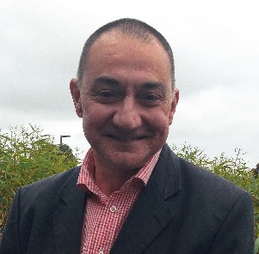
Phillip Taylor: BSc (Hons), MSc, PhD
Philip has almost 30 years of experience as an expert researcher, policy writer and governmental and NGO advisor on workforce ageing. His interests include individual orientations to work and retirement, employer behaviour towards older workers and international developments in public policy aimed at extending working life. He holds professorial positions with the University of Melbourne and Federation University Australia and is a research fellow in think tank Per Capita's Centre for Applied Policy for Positive Ageing (CAPPA).
Philip attended 5 out of 5 meetings
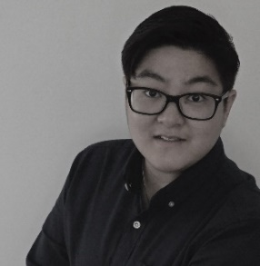
Queenie Tran: BArch, MArch
Queenie has developed extensive experience in architecture and access consulting. She has provided expert guidance in accessibility with relation to residential, health, commercial and industrial projects. In 2010, Queenie established ‘Wall to Wall Design + Consulting’ as an architectural design and consultancy practice with a commitment in developing functional and aesthetic solutions, inclusive of all people and their needs. More recently, Queenie has been working with the NFP sector to increase the supply and quality of housing for people with disability, including Summer Housing as the Housing Projects Manager.
Queenie attended 4 out of 5 meetings

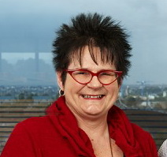
Joe Manton: Cert IV, TAA.
Ms Joe Manton is an accredited access consultant and is managing director of Institute of Access Training Australia. Previously she was Director of Health and Community Services at the City of Heidelberg in Victoria where she was responsible for services to children, youth and aged and disability services.
Joe attended 3 out of 5 meetings and resigned as a director at the end of June 2016.

Financial Statement for 2016-2017

Income and Expenditure Statement for Year 2016-2017
Income | $ |  | Expenditure | $
Balance b/fwd 30/6/16 | 402.98
Membership fees | 1,450.30 |  | Meeting expenses | 130.60
Donations | 650.00 |  | Insurances | 1,098.28
Workshop fees | 800.00 |  | ASIC fees | 1,176.00
Bank Interest | 5.79
TOTAL | 3,309.07 |  |  | 2,404.88
 |  |  | Balance carried forward as at 30 June 2017 | $904.19

