Travel by australians

Year Ending December 2020
OVERNIGHT SPEND |  | OVERNIGHT TRIPS |  | NIGHTS
FIGURE | % | FIGURE | % | FIGURE | %
$45.6 billion | Down 43% | 72.5 million | Down 38% | 275.4 million | Down 34%
A myriad of varying restrictions and border closures due to COVID-19 impacted travel for much of the 2020 calendar year. Results for the year ending December 2020 continue to show the effects of a year devastated firstly by bushfires then by the global health pandemic from COVID-19. However, signs of improvement can be seen in the December quarter with Australians taking more overnight trips than at any time since the start of the pandemic.
Overall, domestic overnight trips fell 38% to 72.5 million in the year ending December 2020, resulting in a decline in spend of 43% or $35.1 billion to $45.6 billion. Further losses of $8.9 billion were seen in results for domestic day travel bringing the total domestic tourism losses for the year to $44.0 billion when compared to the 2019 calendar year (Table 1). Additionally, international travel observed losses of 76% or $34.3 billion, bringing overall losses for tourism to $78.3 billion for the year.

TABLE 1: TOURISM SUMMARY, 2019 and 2020 Calendar Years

spend ($ billions)
 | 2019 | 2020 | Change
Overnight | 80.7 | 45.6 | -43%
Day Trip | 26.3 | 17.4 | -34%
INTERNATIONAL | 45.4 | 11.0 | -76%
Total | 152.4 | 74.1 | -51%

Visitors (millions)
 | 2019 | 2020 | Change
Overnight | 117.4 | 72.5 | -38%
Day Trip | 248.3 | 164.2 | -34%
INTERNATIONAL | 8.7 | 1.7 | -80%
Total | 374.5 | 238.4 | -36%

INTERSTATE and INTRASTATE TRAVEL
COVID-19 related travel restrictions and border closures have heavily impacted interstate movement. With Australians switching to travel within their home state the share of intrastate overnight trips and spend increased across all states and territories in the 2020 calendar year. Nationally, the share of overnight intrastate trips increased from 67% to 81% for overnight trips and 44% to 67% for spend.
While both domestic overnight intrastate and interstate travel fell during the year the losses in interstate overnight trips and spend were much greater than for intrastate. Nationally, interstate overnight trips fell 65% to 13.6 million and spend fell 66% to $15.2 billion. In contrast, falls in intrastate overnight trips and spend were 26% to 58.9 million and 15% to $30.4 billion. This was consistent across the country with losses in interstate travel much greater for all states and territories (see Figure 1).

FIGURE 1: PER CENT LOSS IN INTERSTATE AND INTRASTATE SPEND BY STATE, YEAR ENDING DECEMBER 2020¹

¹ Due to an insufficient sample intrastate ACT is not shown

Capital Cities and Regional Travel
Capital cities have been hit harder by the pandemic (see Figure 2). During the year ending December 2020, overnight trips to capital cities fell 52% to 23.3 million trips. Comparatively, overnight trips to regional areas fell 30% to 51.6 million. The contrast in falls between capital cities and regional areas was even greater for spend. Spend in capital cities fell 60% (down $23.3 billion) to $15.7 billion while spend in regional areas fell 28% (down $11.8 billion) to reach $29.9 billion. This disparity in overnight trips and spend between capital cities and regional is even greater in the December quarter 2020 (see Figure 6).

FIGURE 2: PER CENT CHANGE IN OVERNIGHT TRIPS AND SPEND TO CAPITAL CITIES AND REGIONAL AREAS, YEAR ENDING DECEMBER 2020

AccomModation
Overall visitor nights fell 34% (down 142.5 million nights) during the year ending December 2020. Although, there are some encouraging signs of improvement in the December quarter, hotels, motels, resorts and service apartments continued to see large declines due a heavier reliance on interstate and business travel which continues to return weaker results.
During the year nights in hotels, motels and resorts fell 49% (down 49.5 million). Nights in rented apartments and units were down 29% (down 10.3 million nights) and caravan parks and commercial camping grounds saw losses of 30% (down 10.9 million nights). There was also a 32% or 45.6 million fall in nights spent at a friend or relatives property.
The fall in nights by accommodation type was much greater in capital cities than in regional areas (see Figure 3).
FIGURE 3: PER CENT CHANGE IN NIGHTS BY ACCOMMODATION TYPE, CAPITAL CITIES AND REGIONAL AREAS, YEAR ENDING DECEMBER 2020

STATES AND TERRITORIES
With COVID-19 effects from March 2020 onwards, all states and territories had a fall in overnight visitors and spend for the year ending December 2020 (Figure 4).
FIGURE 4: OVENIGHT TRIPS AND SPEND BY STATE, YE DECEMBER 2020²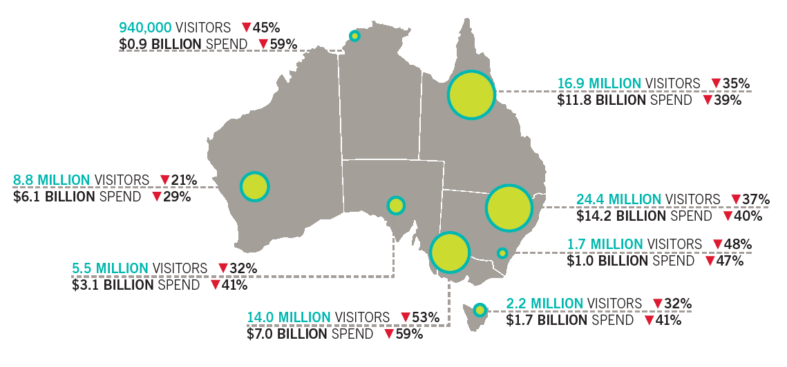
² The sum of the total number of visitors for each state will be greater than the total number of visitors for Australia due to individuals who visited more than one state.

December Quarter 2020
OVERNIGHT SPEND |  | OVERNIGHT TRIPS |  | NIGHTS
FIGURE | % | FIGURE | % | FIGURE | %
$14.2 billion | Down 31% | 21.7 million | Down 26% | 78.7 million | Down 24%

Intrastate continued to drive the recovery in domestic overnight travel in the December quarter. While overnight trip numbers fell 26% (down 7.8 million to 21.7 million) and spend fell 31% (down $6.2 billion to $14.2 billion), this was an improvement on the previous falls of 42% and 53% seen in the September quarter.
Regional areas continued to fare better than capital cities during the December quarter. While capital cities continued to record large losses in comparison to the same period last year, spend in regional areas was stronger in New South Wales (NSW) (up 12%), South Australia (SA) (up 9%) and Western Australia (WA) (up 23%).

INTERSTATE and INTRASTATE TRAVEL
During the December quarter 2020, states and territories saw an easing in restrictions allowing increased movement both within and between state borders. The most significant of these changes was the end of the lockdown in Victoria (VIC) and subsequent opening of the border to other states and territories. Despite outbreaks in SA resulting in a snap three day lockdown and in Greater Sydney before Christmas, results in December quarter were encouraging.
In most states including NSW, Queensland (QLD), SA, WA, Tasmania (TAS) and the Northern Territory (NT) intrastate trips and/or spend increased during the December quarter 2020 in comparison to the same period last year. In contrast, the large domestic overnight tourism market of Victoria (easing out of restrictions from its second lockdown) continued to see a fall in both intrastate trips and spend (Figure 5).
While nationally intrastate trips in the December quarter fell 6% (down 1.2 million), spend was up by 22% (increasing by $1.9 billion). The increased spend came on the back of intrastate nights increasing by 5%, with travellers in most states and territories taking longer trips on average in their home state.
Interstate trips saw an increase during the December quarter compared with the September quarter 2020. However, nationally interstate overnight trips during the December quarter were still down 65% (down 6.5 million trips) to 3.5 million and spend 70% (down $8.1 billion) to $3.6 billion on the same period last year.

FIGURE 5: INTRASTATE PER CENT CHANGES IN OVERNIGHT TRIPS AND SPEND, BY STATE, DECEMBER QUARTER 2020³

³ Due to an insufficient sample intrastate ACT is not shown

Capital Cities and Regional Travel
During the December quarter 2020, regional areas continued to fare far better than capital cities (Figure 6). Regional areas have benefited by being less reliant on interstate and business travel and relatively free of COVID outbreaks. These areas have been key destinations for capital city residents looking to enjoy a break particularly in their home state.
Overall, overnight trips to regional areas declined 11% (down 2.0 million) to 15.9 million and spend fell 2% (down $228 million) to $9.9 billion in the December quarter 2020. In comparison, overnight trips to capital cities fell 49% (down 6.3 million) to 6.5 million and spend fell 58% (down $6.0 billion) to $4.3 billion.

FIGURE 6: PER CENT CHANGE IN OVERNIGHT TRIPS AND SPEND TO CAPITAL CITIES AND REGIONAL AREAS, DECEMBER QUARTER 2020

