Designing public transit systems for accessibility and inclusion of people with cognitive impairments
Author: Emily Ong, Project Lead and Co-Chair of DAI ED-SiG
A safe, inclusive, and accessible public transport is more than ramps, lifts, and barrier-free features such as a tactile guiding system. It must enable commuters of diverse abilities to experience mobility easily and have the confidence to use public transport with minimal assistance or independently.
In Singapore, the Land Transport Authority (LTA) has been working with various partners to improve commuters’ accessibility to the public transport system including those with sight and hearing impairments. However, when it comes to accessibility for commuters with dementia, the primarily focus has been on expanding number of Dementia Go-To-Points (GTPs) which serves as designated “safe return points” for members of the public to bring persons with dementia who are lost in train stations, bus interchanges and integrated transport hubs. Many people with dementia would want to maintain their independence, including able to take public transport independently or with minimal support.
Two members of the Environmental Design Special Interest Group (ED-SiG) of Dementia Alliance International (DAI) were invited by Dementia Singapore to be part of the working group of ‘Find Your Way’ initiative with other local dementia advocates and largest Public Bus Operator, SBS Transit. The initiative aims to make it easier for persons living with dementia to navigate within bus interchanges and Mass Rapid Transit (MRT) Stations in Singapore that it manages. ED-SiG was set up with the intention to provide technical advice and promote the implementation of dementia enabling designs that are intuitive to navigate, easy to comprehend and manageable for persons with dementia. It is an international advocacy community comprising of DAI advocates, care partners, and technical experts, including eminent researchers, architects, gerontologists, clinicians, occupational therapists, and accessibility experts.
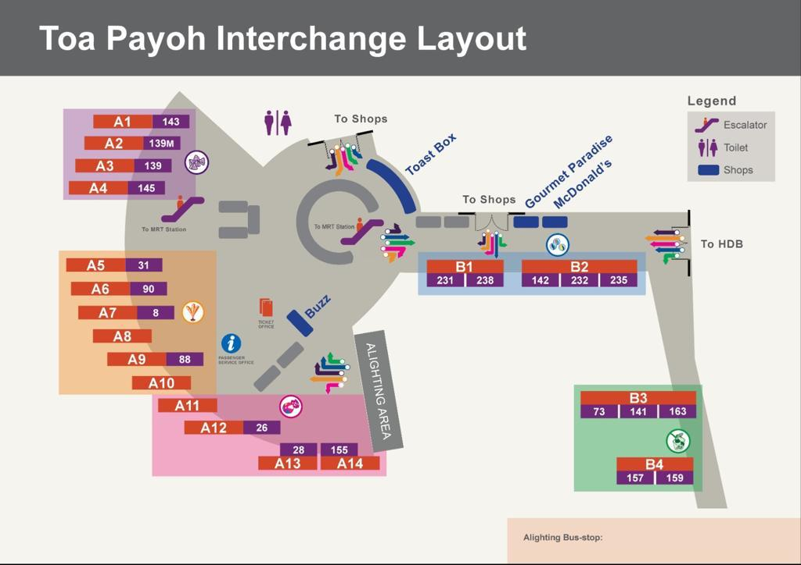
The floor plan of the Toa Payoh Bus Interchange (Photo: SBS Transit)
‘Find Your Way’ project is the first of its kind in Singapore where a bus interchange is color-coded into distinct zones and represented by an image of a nostalgic childhood game. The usage of color helps to create the spatial zoning organization that makes it easier for persons with dementia to perceive the space and find information in a busy and complex environment like a bus interchange.
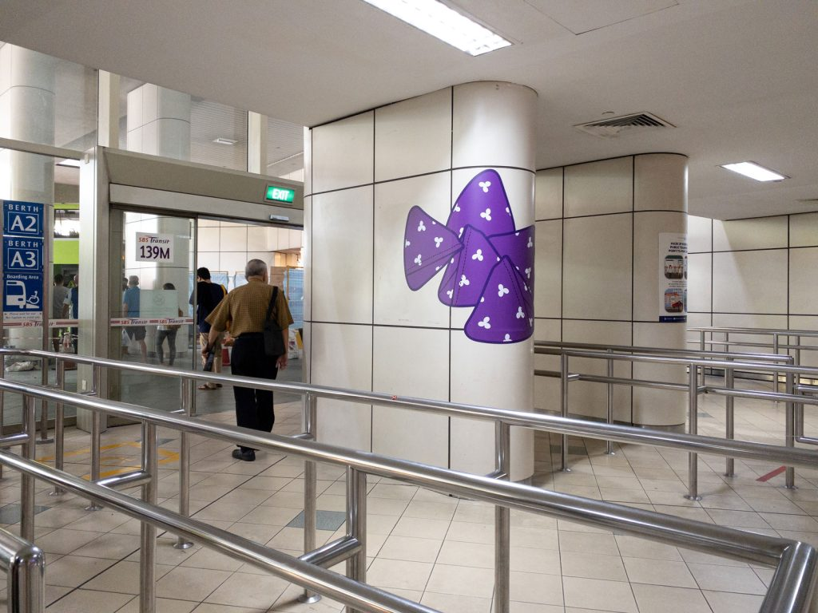
The purple five stone, a nostalgic childhood game. (Photo: Dementia Singapore)
The incorporation of a nostalgic childhood game is part of providing information in multiple formats and through multiple pathways. Another key feature is the placement of big directional arrow stickers on the floor, which are more intuitive for persons with dementia. The chances of missing the visual cues is less, thus making it easier for persons with dementia to orientate themselves and find their way to the bus berths.
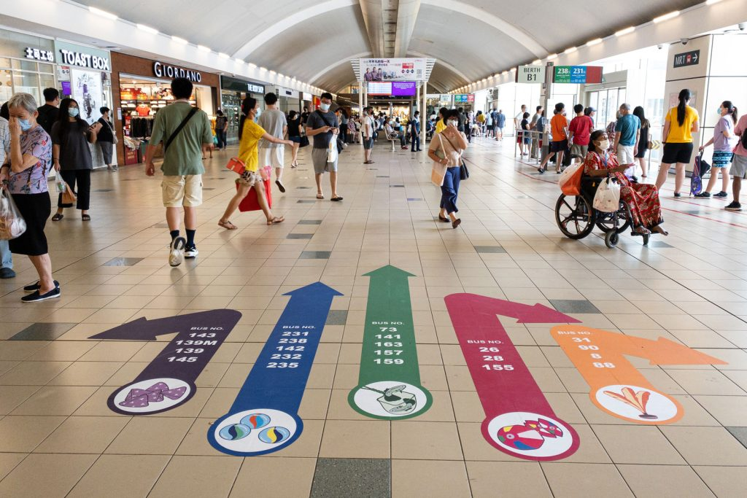
The directional floor arrows with images and bus services. (Photo: Dementia Singapore)
People living with dementia have indicated that this approach has made it easier to use the interchange and made them less anxious about finding their way at the bus interchange.
If interested to join or collaborate with DAI ED-SiG, please contact Emily Ong at https://www.dementiaallianceinternational.org/contact/
Other relevant links:
Write-up on the website of SBS Transit: https://www.sbstransit.com.sg/findyourway
Write-up on the website of Dementia Singapore: https://dementia.org.sg/2022/02/07/find-your-way

