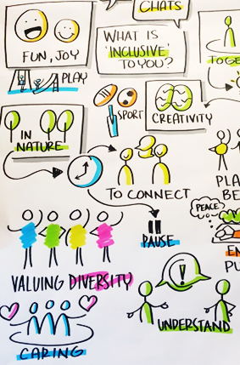
What Makes Inclusive Communities?

Meanings, Tensions, Change Needed

Stage 1a Summary Report - Planning Inclusive Communities Project
Authors: Dr Lisa Stafford, Matt Novacevski, Rosie Pretorius, Pippa Rogers
Date: 2023

Citation: Lisa Stafford, Matt Novacevski, Rosie Pretorius, Pippa Rogers. (2023). What Makes Inclusive Communities? Planning Inclusive Communities Research Project Stage 1a Report. University of Tasmania.
ISBN: 978-1-922708-42-7
Contact author details: Dr Lisa Stafford email: lisa.stafford@utas.edu.au or phone 03 6226 2143
Cover Image. Drawing from visual graphic recording of one of the community chats by Kylie Dunn, dinkylune https://www.kyliedunn.com/
Research Ethics. QUT Ethics Approval Number: 1900000898 (lead agency for stage 1).
Research Funding: Australian Research Council – DECRA Fellowship DE190101512
Use of Language. The language of disabled people (identity first language) is used in this report in line with social and critical models of disability that recognised that people are disabled by society due to structural, attitudinal systemic injustice in practices and systems not through body-mind diversity. However, it is acknowledged that people identify in many ways, and person-first language (persons with disabilities) is also used in Australia. Both are accepted languages.

Stage 1a -People and Partners
Research team: Lead Researcher - Dr Lisa Stafford, Research Assistants: Rosie Pretorius and Matt Novacevski, Expert by Experience Project Assistant: Pippa Rodgers.
Research Partners
- Clarence City Council, Tasmania
- Gympie Regional Council, Queensland

Acknowledgements
Project participants
A huge thank you for taking the time to be involved in the project and share your knowledge and experiences. Without you, our project isn’t possible.
Project Partners and Supporters
Julie Andersson, Allyson Byrne, Eadie Hancok, Andree Stark, Keren Franks, Corina McCarthy, Disability Voices Tasmania, Mission Australian PITC, THS-Health Promotion and Young Leaders of Tasmania, Queensland Disability Network. Members of Gympie and Clarence local advisory groups 2020.
Acknowledgement of Country – Research locations
We wish to acknowledge and pay our deep respect to the palawa/pakana people as the ongoing custodians of the ancestral land, seas and waterways of lutruwita/Tasmania. Wish to acknowledge and pay our respect to Gubbi Gubbi people, the traditional and ongoing custodians of the ancestral land located in South East Queensland, within the Moreton Bay, Sunshine Coast, Noosa and Gympie region.

Introduction
The Right to Inclusive Cities and Communities is more relevant now than ever before as social-economic and spatial inequalities continue to grow, while wellbeing is impacted by decades of poorly planned, -designed, and -invested in cities and communities. Exclusion in everyday life experienced by disabled people and chronically ill people also persists despite decades of reforms including access standards, disability and anti-discrimination legislation, and Australia being a signatory to the UN Convention on the Rights of Persons with Disabilities (CRPD).
The United Nations has set global Sustainable Development Goals (SDGs) to be achieved by 2030 – Goal 11 is to make cities and human settlements inclusive, safe, resilient, and sustainable. Inclusion, and equity are recognised as key principles to addressing disability, class, gender and age inequality and discrimination.
While Australia is a key signatory to CRPD and SDGs, there is little clarity as to how it might be achieved. Significant gaps persist in urban planning systems, theory, and practice. Additionally, disability and urban policy is rarely connected. This begs the question: How do we make communities and cities more Inclusive, when exclusion is persistent and embedded in systems of planning and design?
Addressing this question starts with returning to the grassroots, asking and establishing what makes communities inclusive for all people.
This stage 1a report shares the key insights to this question from 97 people with and without disabilities aged nine to 92, from Clarence and greater Hobart in Tasmania and Gympie Region and surrounds in Queensland, Australia.
Participants shared thoughts, experiences, and ideas of what makes communities inclusive and their current experiences of living in their communities.
This report shares:
- The Makings of Inclusive Communities: Overall meaning established and the 5 core elements that make communities inclusive.
- The Tension Points: What’s stopping communities from being inclusive.
- The Change Needed: The key areas where change is needed to make communities more inclusive.
We also discuss the next steps in this research project.

PROJECT CONTEXT
The Planning Inclusive Communities (PIC) project stems from years of research and practice by Dr Lisa Stafford on mobility, participation, and the diverse experience of everyday life in the planned and designed city centres, towns and neighbourhoods of Australia. The PIC project was funded by the Australian Research Council as part of a DECRA Fellowship enabling Dr Lisa Stafford to bring to life the idea of co-creating deeper understanding and transformative practice of planning inclusive sustainable cities and communities with passionate disabled people/people with disabilities, family members, urban planning and community development practitioners, allies, and communities.

Why does this project matter?
- Currently 3 in 10 disabled people experience difficulties in accessing locations (AIHW, 2022) due to planning and design of everyday spaces and infrastructure overlooking body-mind diversity and the different ways people occupy, move, sense and experience space (Stafford, Vanik, Bates, 2022).
- We have a legacy of poorly planned, designed, and invested-in neighbourhoods and urban centres. These environments have been shaped by inadequate and unfair urban policies and practices that have had a significant negative impact on wellbeing and have reinforced oppressions of a number of people and communities (Sanoff, 2000; Marcuse, 2015), many who are people with disabilities, neurodiversity, and complex mental health needs.
- In the face of climate change, and growing urban segregation, poverty, and inequality – deliberative planning with equity and inclusion is critically needed to ensure just adaptions for all people and communities (UN SDGs, UN Habitat III).

Why are we centring Disability and Mental Health?
- Body-mind diversity is a natural part of being human.
- Every one of us will have an experience of disability over our lifetime – be it direct or be it the experience of a loved one.
- 4.4 million or 1 in 5 Australians have a disability – In Tasmania this is more than one-in-four people - 26.8% and 18.3% in Queensland (ABS SDAC 2018).
- Over 8 million people or 31.7% of the Australian population had at least one long-term health condition. (ABS Census 2021)
- Nearly 1 in 2 (46%) Australians aged 16–85 experienced a mental illness during their lifetime (AIHW, 2022).
- Disability is diverse. It can be visible but is mostly invisible. Disability can also be episodic.
- People with a disability can be any age, race, gender and class. Socio-cultural factors often exacerbate the environmental exclusions of people with disabilities.
When we considered these facts, it is a necessity that urban planning thinks and acts more deliberatively in how to plan and design our environments to be just and inclusive for all.

Overarching Project Aims
The aim of this 3 ½ year research project is to build knowledge to help plan more inclusive communities and cities that benefit everyone, while actualising the rights of disabled, neurodiverse, and chronically ill people.
Three key questions this project seek to answer:
- How is inclusive community understood by diverse citizens at the local community level?
- How are access and inclusion currently incorporated in planning practice, and to what extent do tensions still exist?
- What would a model of planning inclusive community look like, and what actions are needed moving forward to plan more inclusively?

The Project Plan
The project was envisioned initially as a three-year endeavour. It started in 2020 with the plan to finish in 2023. However, the COVID-19 pandemic’s impacts on our ability to conduct engagement have required timelines to be recast and the project is now expected to finish in mid-2024. The PIC project has three parts:
- Stage 1a - finding out what makes a community inclusive - 2020-2021 – The focus of this report.
- Stage 1b - identifying occasions and tensions in doing access and inclusion in urban planning practice - 2021-2022.
- Stage 2: co-creating a model of planning inclusively - 2023 - mid 2024.

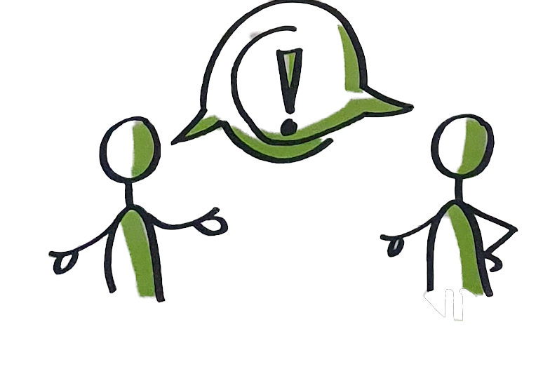

Background: Inclusion in Planning Cities and Communities

Concept review: Inclusive Communities and Cities
Inclusion, Equity and Fairness features strongly in global urban sustainable development initiatives and movements in response to growing inequity and segregation experienced in cities and communities.
Inclusive communities, cities, societies have been defined by the UN since 1990s to include: valuing and embracing diversity across race, gender, class, ability, generations and geographies; ensuring the rights and freedom of all people are upheld; and ensuring the needs of marginalized groups are responded to and safeguarded (UN DESA, 2007).
In 2016, at UN Habitat III, integrating equity in urban development was a key feature of the new urban agenda. Under this policy “equity becomes an issue of social justice, ensures access to the public sphere, extends opportunities and increases the commons” (Habitat III, 2016).
While inclusion and equity are firmly promoted in these global urban strategies and are fundamental to planning and design of our cities and communities – these concepts have not been well translated nor embedded into urban planning systems and practice (Baldwin and Stafford, 2019).
There are many reasons for this:
- Ambiguity and application of the concept of inclusive community.
- The pervasiveness of disablism and ableism in society that influences the planning profession.
- Tenuous environment to practice inclusion and equity in urban planning.

Challenge 1: Ambiguity with the concept of inclusive community.
Despite being used extensively in social and spatial justice discourse and policy agendas, the meaning and understanding of inclusive communities is under conceptualised. This has resulted in the contestation of the term on several counts (Bezmez, 2013; Espino, 2015; Azzopardi & Greech, 2012).
Firstly, as Azzopardi & Greech, (2012) note, there is limited understanding and insufficient theorising of the concept “Inclusive Communities” itself (p.14) that has created ambiguity. Scholars have discussed the different positioning of the idea – as a rights-based approach or charity-service based approach (Bezmez, 2013). Furthermore, research has suggested that inclusive community is presented as a normative idea, yet scholars and activist have illustrated the concept can mean different things to different people and have many layers of meaning (Disability Rights UK, 2015; Espino, 2015), as well as different cultural interpretations and realities e.g. global south vs global north (Meekosha, 2011).
Another issue is how it is conceived; that is, as a process or an outcome, rarely as both (Disability UK, 2015). Additionally, inclusive communities are often defined using other key concepts such as inclusion, equity, citizenship, social capital, participation - all of which can have different ways of meaning and conceptualisation. These current conceptual problems pose a challenge for scholars, policy makers and practitioners in the application/implementation of the concept.

Challenge 2: Pervasiveness of disablism and ableism in society.
Disabled people experience discrimination and imposed exclusion in everyday life, due to disabling environments, structures and systems, attitudes and spatial arrangements preventing their full participation (Stafford, 2014; Goodley, 2014; Imrie, 2003).
The production of disablement (Oliver, 2009) stems from dominate mindsets and discourses of “normal” & “able” that persist in societies (Stafford & Volz, 2016). This is further reinforced by critical disability rights theorists, such as Goodley (2014), Meekosha and Shuttleworth (2009), Harpur (2009) who describe normative constructs of ableism as forms of prejudicial discrimination that persist and maintain oppression of people with disabilities in all aspects of social-cultural and political economic life.
Box 1. Ableism
Ableism is a prejudice that favours “able” “standard” body-mind while devaluing all others. As Vera Chouinard (1997: 380), outlined this prejudice is based on ‘ideas, practices, institutions, and social relations that presume ablebodiness, and by doing so construct persons with disabilities as marginalized […] and largely invisible ‘others’. Identity, abilities, markets, and built environments and infrastructure have all been linked to this deeply rooted form of prejudice (Campbell, 2009; Wolbring, 2008).
Ableism in Urban planning
The pervasiveness of these dominate discourses are evident in urban planning, such as core infrastructure, programs, and activities planned and delivered by local governments (Imrie, 2001, 2003; Boys, 2014; Baldwin & Stafford, 2019). This has also been conveyed in earlier research leading to this project (see e.g. Stafford 2014; Stafford, 2017; Stafford & Baldwin, 2015, 2018) and recent articles by various authors in the special edition of Disability Justice and Urban Planning (Stafford, Vanik, Bates, 2022), revealing how public spaces and social infrastructure like transport, housing, town centres often exclude access to and use by people with disabilities, preventing their full participation.
We also know that mobility and participation are deeply entwined and our sense of connection, wellbeing, and belonging, is intrinsically linked to our opportunity to enact our spatial agency (Stafford, 2022b). As such, an important component of building inclusive communities and cities, is to challenge normative thinking that underpins the planning, design, funding and delivery of these everyday spaces and infrastructure.

Challenging 3: Tenuous Environment to Practice Equity and Inclusion
Well-known urban scholars and advocates like Jane Jacobs (1961), Paul Davidoff (1965) and David Harvey (2008, 2009) signaled concern for the erosion of public spaces and commons. Critical planners established that capitalism was driving inequity in access, use, and rights to our cities and neighborhoods, through the commodification and privatization of homes, streets, and public and natural spaces.
At the same time the social and community aspects of planning was being eroded from practice requirements. Whole practice movements like community design (planning and designing for and with diversity of people and communities), grew out of this concern. As Sanoff (2000, p xi) noted the community design movement emerged from the “realizations that the mismanagement of the physical environment is a major factor contributing to the social and economic ill of the worlds and there are better ways of going about design and planning”.
Research since has shown how the emphases of new urbanism, economic growth, and technical rational practice in urban and regional planning has played a role in creating and maintained exclusion in community (Thompson, 2012; Vavik & Keitsch, 2010). Such influences have also meant differences has emerged in how planners see their role in planning for community and inclusion (Moon et al., 2014); varying understanding of importance and practice of community design/planning by urban planners (Shevellar et al., 2015); and a reduction in the scope of work of “social and community” to technical roles in statutory social impact assessments where required in development assessment (Gleeson & Steele, 2010). This has been aided by planning research where disability has remained largely invisible, and disabled people’s voices basically missing (Terashima & Clark, 2021).
The impact of these economic and urban policies and the emphasis on the technical only has meant inclusion and equity has not been taking seriously nor embedded in urban planning systems and education (Schatz & Rogers, 2016; Stafford, 2020a), and these dominate processes and practices in urban planning and design have further entrenched injustice and exclusion (Fainstein 2014, Pineo 2020, Soja 2010, Stafford 2022, Stafford et al., 2022, Ng 2022).
Summary
The persistent challenge to progress planning for inclusion and equity in communities and cities - entails addressing these interconnected challenges leading to exclusion experienced by disabled people at varying levels; and the limited applied understanding of doing inclusive urban planning and design practice at the local level. These are important issues that need to be addressed to influence change, yet ones that have not received significant attention.
Addressing these tensions and gaps in practice is central to this research, as well as foregrounding body-mind diversity if we are to dismantle ableism and achieve equity and inclusion in cities, neighbourhoods and streets for all people.

Policy Context – Disability and Urban Policy
The policy context plays a key role in discrimination and exclusion faced by disabled people every day in the built environment and systems. Understanding the tensions and gaps that need addressing to help shape more equitable and inclusive cities and communities is important as well as how well polices talk together. A key issue in Australia is that urban policy and disability policy rarely speak to each other let alone integrated. Before highlighting the tension, it is important to start with the significant disability policy reforms recent in Australia.
Australian Disability Policy Reforms
Australia’s significant disability policy and services reforms in 2000’s came about because of key drivers and significant activism led by disabled people, families, and allies including Every Australian Counts campaign commencing in 2011. These are important to understand in the context of this research and urban planning practices.
Key Driver 1: United Nations’ Convention on the Rights of Persons with Disabilities (CRPD) ratified by Australia in 2008. The CRPD was significant in providing the foundational principles from which to advocate for change and defend the rights of people with disabilities in Australia.
Key Driver 2: The National People with Disabilities and Carer Council’s Shut Out: The Experience of People with Disabilities and their Families in Australia Report 2009, contextualised the ongoing problems that people with disabilities and their families encountered in everyday life. The report found: “virtually every Australian with a disability encounters human rights violations at some point in their lives and very many experience it every day of their lives” (National People with Disabilities and Carer Council 2009, p. 4). The report detailed accessing services, spaces and infrastructure, and obtaining full participation and social inclusion as major barriers disabled people face.
Key Driver 3: The Productivity Commission public inquiry into Disability Services in Australia identifying wide-ranging systemic issues and disparities across Australia’ states and territories and recommending need for a long-term disability care and support scheme.
These key drivers led to the development of National Disability Strategy 2010-2020, the COAG agreed National Policy outlining a 10-year national plan for improving the lives of people with disabilities, their families, and carers - of which creating inclusive cities and communities is a Key Policy area, as well as the establishment of the National Disability Insurance Scheme. This historical and significant paradigm shift and policy development in Australia has placed greater recognition of disabled people and strengthens the responsibilities of urban planning and design.
Tensions: Disconnected Disability and Urban Policy
Today, many of the same social-spatial exclusion issues remain despite the Commonwealth Disability Discrimination Act being in place in Australia since 1992 prohibiting direct and indirect discrimination in our built environments inc. streets, transport, parks etc. While there is strengthening interest and responsibility to plan communities and cities for all, outside of buildings structures (both codes and standards), there is little tangible and translatable policies and codes to guide on the ground planning practice of our cities, transport, neighbourhood – streets, public spaces with respect to body-mind diversity.
Part of this oversight is that disability policy remains disconnected from urban policy and planning systems. The lived, everyday exclusions facilitated through planning and design and its processes is not only under-acknowledged, but much less addressed. This is reflected in the second 10-year Australian Disability Strategy (ADS) 2021 – 2031, that has no specified measure in the outcome framework for public space, street, urban planning (See Box 2).
The other problem is that urban planning schemes and policy largely neglects body-mind diversity– beyond compliance tied to legislation such as the Disability Discrimination Act (1992) and National Construction Code (NCC). Seeing disability as an issue of compliance diminishes consideration of body-mind diversity across planning and design thinking and processes, reducing practice to minimum-standard approach (Imrie, 1996). Compliance thinking not only fails to consider and respond to the body-mind diversity - it also stifles good planning practice of cities and communities (Stafford, Vanik, Bates, 2022).
These policy shortcomings and siloing are potentially hindering planning inclusive cities and communities and inhibiting the possibility for place-based approaches. There is much to learn, shift and bring together between disability and urban policies informing day to day practice to achieve inclusive cities and communities.
Box: 2 Australian Disability Strategy (ADS) 2021-2031 p. 11 – Inclusive Homes and Communities
Outcome: People with disability live in inclusive, accessible, and well-designed homes and communities
- Having appropriate housing, and a community that is accessible and inclusive, is central to how people with disability live, work and socialise.
- Accessible housing, transport, communication and the built environment are key factors supporting the participation of people with disability. Accessible public buildings, facilities, parks and events all support the inclusion of people with disability in community life.

ICH - Policy Priority 4: The built and natural environment is accessible.
Adopting universal design principles enables everyone, regardless of age or ability, to use buildings, transport, parks, and playgrounds without the need for specialised or adapted features. Buildings and outdoor spaces that are not accessible exclude people with disability from participation in work, education, and social and cultural life.

ADS Outcome framework: No specific measure for public space, street, urban planning.

Research Design
Lived experience research is a critical starting point to build knowledge and understanding. The approach taken in this first stage of the research focuses on how people understand, live, and make sense of their everyday lives in place.
Stage 1a involved a series of research activities that were co-created to maximise participation and give choice to the diversity of potential participants in how they wanted to be involved. Easy Read materials and videos were provided for each research activity method to further support participation.
These research activities were:
- 1:1 Chats
- Community Group Chats – World Café Style using visual materials to help tell stories, and visual recording of larger community chats.
- Story Board
- Short answer online questionnaire
Each of the methods used and what was involved is outlined on the website https://www.planninginclusivecommunities.com/

Key Questions
The methods all explored the same four questions:
- What makes an inclusive community to you?
- What helps make communities inclusive for people with disabilities?
- What does not help make communities inclusive for people with disabilities?
- What is needed to make communities better for all.
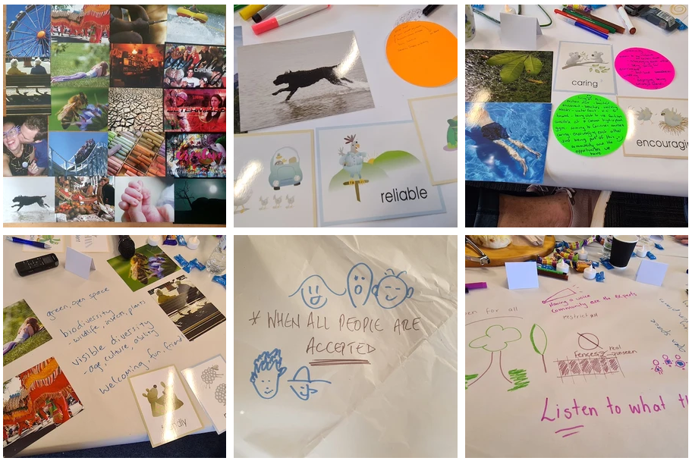
Figure 1. Examples of materials participants used to tell stories.

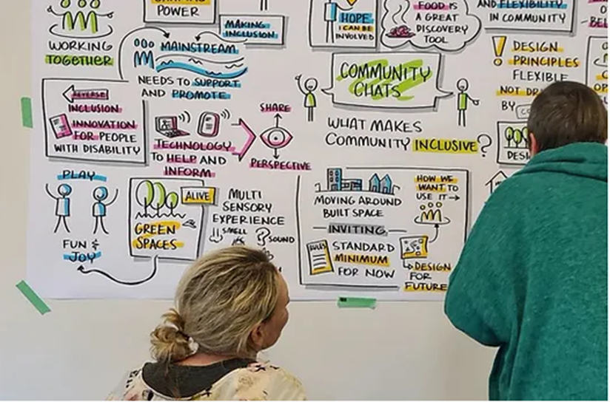
Figure 2. Researcher (Lisa) talking with Kylie (the visual recorder), as Kylie draws ideas from one of the community chats about what makes communities inclusive.

Who got Involved:
Stage 1a involved 97 people aged nine years to 92 years of age sharing their ideas, thoughts and experiences. The participants include a diversity of ages, backgrounds, roles and professions. Half of participants identified as a person with a disability, mental health issues or chronic illness. Others had experience as a parent/carer, community and local government workers.
Participants were from the City of Clarence and greater Hobart area in Tasmania and the Gympie regions and surrounds in Queensland.
The Research received full committee ethics approval from QUT – the lead institute at the time of stage 1 (QUT Ethics Approval Number: 1900000898).

Analysis
A detailed inductive analytical process was undertaken to find the common meaning and elements from people stories, ideas and experiences. This was assisted with using qualitative software NVIVO 12. Themes about what makes communities inclusive were identified by rigorous staged coding process using two coders. This same process was applied to identifying the tensions that stops inclusion of people with mind-bodies diversity across ages and the change needed to foster equity in planning our communities and cities.

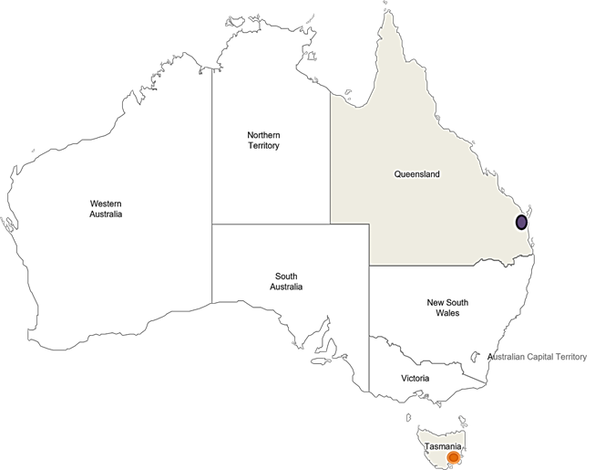Figure 3. Map of the geographical locations of research sites for Stage 1a. Map Source: Free Vector Maps https://freevectormaps.com/australia/AU-EPS-01-0003?ref=atr
The Insights

Emergent Meaning of Inclusive Community
At the heart of an Inclusive Community is its people. A place that engenders a sense of belonging, free to be oneself. Where all people are accepted and valued as they are, and provide a basis where people can take part in activities and interactions of daily life. Inclusive Communities truly embrace, reflect, and are created for diverse body-minds and the different ways we inhabit, sense and experience space. Listening, learning and taking action are linked practices, generated from and within community, and reflective of diverse people’s voices.
Investing in, and valuing infrastructure and spaces that affords experiences, participation and mobility signifies inclusive communities. Places to laugh, create, share, play, to move about, as well as time and space for relaxation, and places to meet up. These assets of community are established with equity – ensuring all people have what they need, and the opportunities, to meaningfully participate and thrive. They also aid future proofing– particularly in the era of climate emergency.
Inclusive communities foster strong connections to people, place and nature. Such connections nourish people - physically, mentally, and spiritually – and provides a sense of wellbeing and belonging.
“I feel like it's all about everyone being able to equally engage in the environment in the community. For people with disabilities there is a lot of restraint, and they can't engage as much as other people. It's also like equality is not enough, it should be equity so everyone has what they need to be able to engage in that community. Because I feel like a community is about people and engagement, but also being able to access and work around a community.“ - Young person

The Five Elements - The makings of inclusive communities
What we heard from participants is that inclusion is influenced by social, economic and built environment structures and systems, but inclusion also happens in place and in movement - at the level of everyday experience.
The research identified five core interconnected elements that signal the makings of an inclusive community and are reflected in how we plan and design communities and cities. These are:
- All people centred public planning processes and decisions (Urban Governance).
- Human Diversity is valued and embedded in all aspects of planning.
- Inclusively designed spaces and infrastructure are assets of community with Equity, Accessibility, Ease as core foundations.
- Planning for connectedness – Nature, People, Place.
- Vibrant places and experiences.

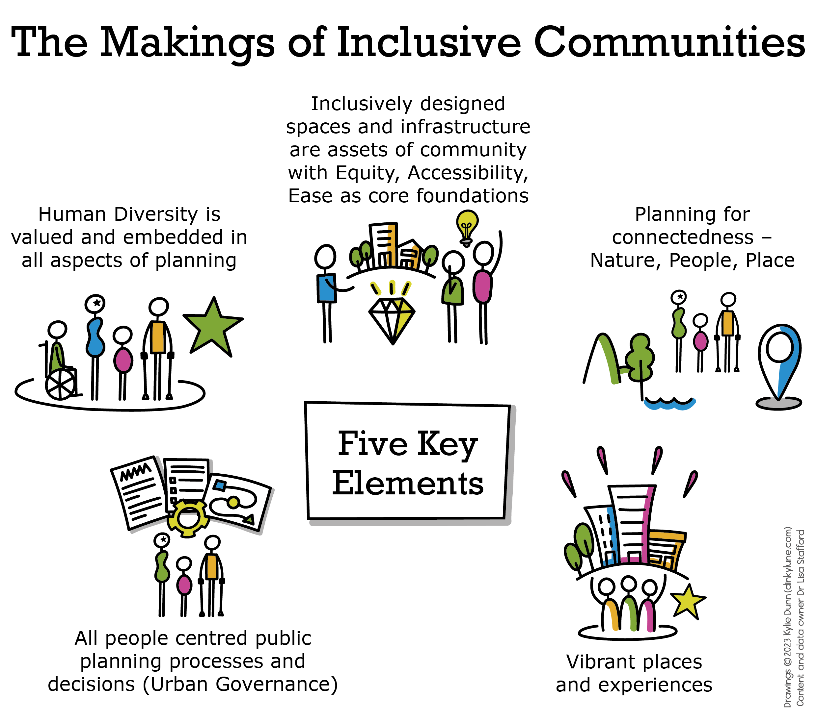
Figure 4: Overview of Key Felt Elements of Making Communities Inclusive
Image Description for alt Text: The image shows five interconnected everyday elements that help make an inclusive community. They reflect planning of communities and cities that all people centred; the importance of connectedness between people, place and nature; the respect and appreciation of diversity; cities and communities foundations are based on equity to enable all people to have choices and opportunities; and the importance of vibrant place to enable connections, participation, and experiences such as fun, belonging, relaxing.
- All people centred public planning processes and decisions (Urban Governance)
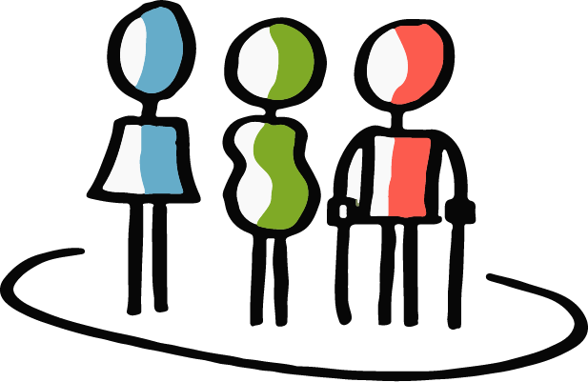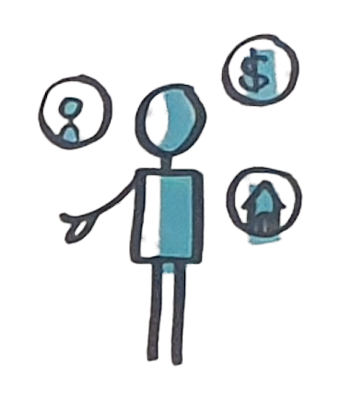
What was heard strongly is that all people must be recognised, respected, and involved in public planning processes and decisions about community and place. This is often referred to as Urban Governance.
Inclusive communities come about through all-encompassing processes that are responsive and support people to be involved in shaping community.
Processes and communication are accessible for all people (diversity of body-minds, ages, languages).
We also heard full involvement is enabled through:
- collaborative development of clear information and participatory planning process and activities,
- having variety of opportunities to be involved including sharing lived experiences knowledge, and
- ideas shared are heard and genuinely utilised to shape decision making.
“Yeah. When it's driven by the community that's what makes it - I suppose - more inclusive. I mean it's to value the place.” Planner participant
“if we think about inclusiveness, accessibility, functionality and safety, and we start thinking about that right from the beginning of anything that we're thinking of planning or designing, and ensuring that part of that brief is having community engagement, but with active participation, not just the website or the Facebook, or whatever. It's like what you're doing now, in terms of actually going face-to-face from the beginning, and ensuring that that active participation, engagement, it starts at the beginning... “
Current experiences heard from participations reveal that planning and decision-making process is often limited to ‘consultation’ that can be token non-participatory and perpetuate exclusion.
“Too often the people with the disability, they’re not seen and they’re not heard, and they – or we - are forgotten about in all aspects of life, in all aspects of being able to plan and be included in things that are going to be to people’s benefit. That includes programs, that includes how cities are planned for, that includes everything really in every single detail. That includes from birth to death.” Participant
“I’m confident enough to reach out and say hi, I need a little support around access. It was just blame shifting. It was like, oh we don’t have the money. Oh, we don’t have the different location, oh we don’t - it was - there was no acknowledgement or offer to provide a pathway towards participation. So how do you get more participation when your whole cohort is shut out of the process of participation? “Disabled person

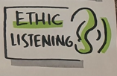
All People-Centred urban governance importantly involves ethical listening and mutual learning, which not only leads to better cities and communities for everyone, it’s integral to developing sense of place, as well as building capacity and strength within and between members.
“I think the more we challenge ourselves and people with a disability, we find more meaning with each other.” LG worker
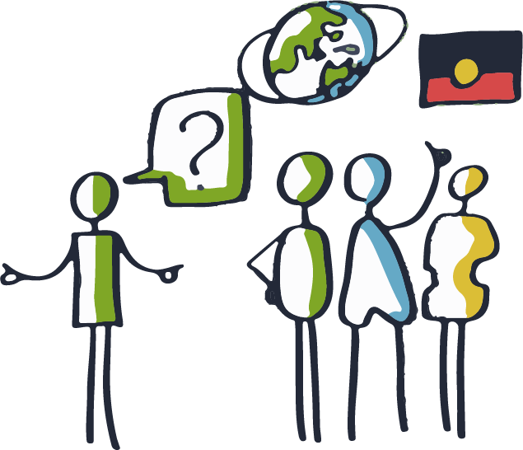
Such inclusive governance approaches also regard local knowledge and lived experience from people with body-mind diversity, cultural diversity, and Indigenous peoples as an asset that improves quality of life and heals mother earth.
Such understanding aligns with Community Design practice (Sanoff, 2000) - where integrating local knowledge in urban planning and design delivery not only improves quality of the design and allows for urban governance to be more responsive to community needs – the environment created stands to improve quality of life and sense of place.
- Human diversity is valued and embedded in all aspects of planning
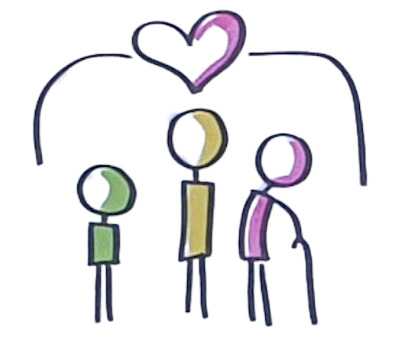
Planning our cities and communities for all people was commonly shared throughout this research. There was a real sense that for inclusive communities and cities to be full realised, planning must accept that as humans we are diverse in minds-bodies and this needs to be centred in how we consider, plan and design our cities and communities.
“So some of our built environments have started to acknowledge that disability and access but it’s still very much built around - the understanding is built around this idea that disability means one thing and it means a wheelchair. So it’s different if you’re on crutches to if you’re in a wheelchair to if you’re on - if you use a walking stick or a mobility walker verse you’re somebody with a visual and you have a cane or a guide dog.” Planner /BE Participant
When we plan for our diversity - we create environments and interactions possibilities that enable people to feel a sense of place – at-homeness feeling. We heard this from disabled people participants and non-disabled participants.
“. …. Not feeling like [sighs] I can't go there, I won't be included, it's not going to be for me, I won't be received well here. But to me, this is a picture of hope that somebody can go wherever it is and in an ideal word that that wouldn't be a factor. Thinking I can just go wherever I want and be included and feel part of life and everything.” Disabled person
This feeling is signalled when all aspect of our designed environment reflects our body-mind needs and ways of being (how we feel, sense, think and move). Such as the approach to layout and movement, wayfinding, environmental sensory load, availability and accessibility of public spaces, the materials and colours, use of nature and landscapes prioritisation and so on.
This point was also reinforced by participants’ current experiences with community environments that do not engender a sense of place– rather a sense of outsider, or just existing - being able to survive was the aim when the environment is not built for you.
“Yeah, well absolutely because people aren’t going to stop being kind but it’s a very difficult thing to - a lot of us don’t like to continually have to put ourselves in a position where we are relying on the kindness of strangers for our survival. When you’re talking about accessibility, it often is really directly linked to a sense of being able to survive in your own environment. So it’s very confronting”. Disabled person

“So from that point of view, taking him to places, things like textures and sound and lighting and lots of crowded places and unfamiliar places present some physical things for him as well…. So I think if people are truly included in things and things are there to support people to be, we truly want to have these really inclusive places, we shouldn’t be coming up against those things. I have no idea what it’s like for anyone else who is dealing with different types of ability as well, so that’s, I guess, my experience with that, from a personal level, is my son, from that perspective.” Parent of person with a disability
The research reinforced that who we are planning for is a core questions that needs to be embedded, asked and reflected upon in all aspects of planning and design practice.
- Inclusively designed spaces and infrastructure are assets of community with equity, accessibility, and ease as the core foundations.

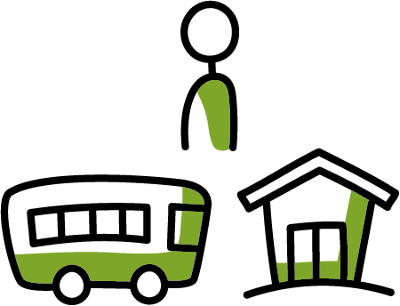
How we plan – through our policies, processes, and approaches - can either open or reduce choices and opportunities to be part of everyday life.
What we heard is that access, equity, connectivity are foundations for planning and design our cities and communities.
“I suppose what makes community inclusive is being able to access the same facilities and same areas that everyone else can in a community, and we shouldn’t have to fight to do it. I suppose that comes down as well is just on [basic accessibility], facilities, day-to-day things around community. I suppose that’s probably [about it]. But I’ve got a card that’s – so understanding, you’ve got a frog on a couch and a crocodile sitting in the chair beside him. So I suppose people need to understand that we don’t expect – people with disabilities don’t expect anything special, we just want to be able to access community like everyone else.” Disabled person
“I want people to be able to go to places, be included in things and not have to think twice, oh my gosh, like are they going to accommodate me here, actually can I just get in the bloody building, you know? We don’t want that, so you just want to be part of life.” -Disabled participant
Taking access, equity and connectivity seriously and embedding this in day-to-day practice requires moving beyond building codes or compliance with minimum standards, to a performance-based approach where planning for all with equity and inclusive design is the accepted practice.
Inclusively designed spaces and infrastructure are considered core assets of community and foundations for choices and opportunities.
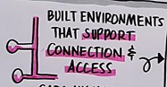
Movement, Connectivity, and Place
When we plan for our body-mind diversity from the perspective of equity and full participation, we cannot help but have communities that are better connected.
“A built environment that provides the greatest possible movement and access” Disabled person
Connectivity was considered a key foundation that allows all members of the community to come together, to move about freely – enact spatial agency, to do everyday routines, and have the same opportunities and choices to be part of everyday life.
Connectivity can be achieved in urban planning areas transport, strategic planning, urban design and open spaces when we place inclusion and equity at the heart of planning.
“I talk about movement and place, so how we move around and what is a place. We talk about connection and being welcoming. Openness and enabling - having a lot of people around and that's why I kind of chose this card because it's just pretty sad sort of environment where you're in an urban area and there's not that many people around, you're the only one entering that space.” BE- Planner participant
Inclusive Streets
At the neighbourhood street level, we heard that key to enabling connectedness is movement and refuge. Our local street design plays a role in affording safe people movement and connectedness.
“I'm talking about me and my community and from the time five years ago when I became a person living by myself and joining in my community. I find that friendship is one. You pass by people in the street and you speak and notice.” Older person participants
“Just enabling people to get around would be jolly good.” Older person with a disability
Part of this is having the basics (core requirements) in place to facilitate people movement (footpaths and curbs). Core requirements like footpaths are considered essential service requirements in any new development or renewal project. And that footpaths and walkways can be done in a way that is responds to diverse body-mind needs.
“So it’s possible to include both, right? You could have a walkway - you could have clear walk paths that have tactile indicators and then you could have walk paths adjacent that people have access to. So it’s about acknowledging and being aware and building from the beginning rather than trying later on to adapt.” LG worker
From the data collected in this first stage, inclusive neighbourhood development occurred when planned and designed for all people’s movement choices and dwelling:
- reflective of all people: our diversity in body-mind, gender, age, and culture.
- responsive to our different ways of moving about: walkable, wheelable, pushable, rideable – inclusive of all people from the start, particularly people with disabilities and children – often excluded voices.
- provide equity in mobility opportunities in all aspects: whether for purpose, joy, or wellbeing
- facilitate connections when moving about our neighbourhoods: with people, nature (inc street street) and places
- include spaces to pause, rest, talk - it shouldn’t be designed for go go go!
Inclusive Active and Public Transport
A central priority in an inclusive community is connected, accessible, safe and reliable transport (both active and public transport inc. community transport).
Multi-modal transport in our communities and cities provides people what they need to get about their local and broader areas, to study/work, to access key services, socialise, or to feed their families. We heard strongly how transport is a key connector of life!
To enable equity, inclusive communities would be based on all people – our body-mind diversity, and on whole of journey approach to planning for movement and place in and between communities in regions.

“Don't build a bike lane that's just for people who normally ride bikes. If it's not a protected bike lane with a barrier there, then someone who is eight is probably not going to use it, someone who is 80 is probably not going to use it.” BE participant
This would entail:
- available, affordable, safe, reliable and fully accessible public transport with good connections between modes of transit, such as walking/wheeling infrastructures.
- Safe footpaths and bus shelters as key to ease of movement, safety, and continuous path of travel.
- Convenience and frequency of public transport services was also raised as important in ensuring spatial agency.
It also was raised in terms of environmental sustainability – offering dependable alternative to car dependence and help to reduce greenhouse emissions.
The current reality is that transport is a key barrier to inclusion in cities and communities. This was particularly felt for many disabled people, people with complex health needs or lack of mobility, low-income families, young people - lack of access to transport was heard as a barrier to participation and a driver of isolation and exclusion.
“Transport is a big issue for me for inclusive communities, coming from a community where the transport's gotten a little bit better, but it's not fantastic. Yeah and find that that's a bit hard, so that can make it really hard for our kids to be included in a lot of things, because that – and yeah, just walking, good walkways, seating and people looking out for one another. Yeah, they were my main take homes..” LG worker /Person with Disability
“So I think when people think of transport, it's important to see – I'm sure we all do, but it's not just about the A to B and getting to a job or a sport. It could be as simple, as basic as feeding your family or yourself.” Parent of person with disability/LG Worker
Inclusive Open and Public Space
Other core infrastructure and spaces considered essential in inclusive cities and communities is open spaces and gathering spaces. Much was spoken about in terms of importance of inclusive just public spaces for all people. This included parks and playgrounds, natural environments (beaches, bush), active streets and activity centres. There were examples of progress being made, but many barriers still remained in all of these areas in terms of engendering meaningful experiences, genuine participation, connectedness.
“but another thing would be bush walks or going away for bike rides.” Older child
“Regarding Men’s sheds…why can’t there be a woman’s shed as well?...When they opened up I went in and said, “this is a bit unfair, why can’t there be a women’s shed?” And he said “yes, we’re thinking about starting one” but that was about five years ago.” Older person
“...for me it was about access to nature. … too often access to nature is from a carpark, and it means it’s not accessible to everyone.” Disabled Person
Inclusive housing is part of community
Having safe secure shelter in community was a basic of an inclusive community. Housing was not seen as a commodity, but core community asset that fosters connections, spatial movement and “village life”.
However, it was acknowledged that in current society, inclusive is far from reality, as there was a growing divide in access to affordable and accessible housing and locations that enable connections.
“Yeah, and I think that we need to do more of that. We need to stop just building big broad acre environments and stop banging on about, you know, affordable housing, it really shits me. Oh, we’re going to build affordable housing. I don’t see that. I don’t feel it. I don’t feel that integration.” LG worker/Disabled Person
“The other bit that I’m particularly interested, in my role in the Precinct Plan, is affordable housing, for instance. So I see that young people nowadays don’t have some of those choices that I had growing up, and just me being lucky in the era that I grew up in.” LG worker
Community Assets (Inclusive Spaces and Infrastructure) Foster Choices and Opportunities
How our communities and their relationships to neighbouring areas and cities are planned, designed and built for diversity of people have a significant influence on choices and opportunities to move about and participate in all aspects of live.
“I put down was feeling safe, and interestingly, and to participate. I guess it’s – and I’ve also got having many futures and choices. So I think they’re sort of related to each other and, yeah, I particularly would like to share something. I come from a background of growing up with a single mother and not having a lot of money and going to a school that wasn’t a terribly good school, I’ll say, and fighting to survive in that environment. Yet I have been able to have lots of choices in my life. So I’d like other people to have that as well.” LG worker
“I guess for me inclusive communities is all about empowerment and opportunity. What I’m thinking in particular is empowerment and opportunity around employment and being able to make the choice that everybody – that every other person in the community gets to make, regardless of whether you have a disability of not. “ Disabled Person
“I also had opportunity down there, because I think sometimes you sort of go along through life and if you don’t get provided those opportunities, it’s really hard to make informed choice around what you can do. So if nobody actually shows you what is possible, then you really can’t sort of follow the path that you would have done if you had have had those opportunities put forward.” Disabled Person
- Connectedness to Place, People and Nature
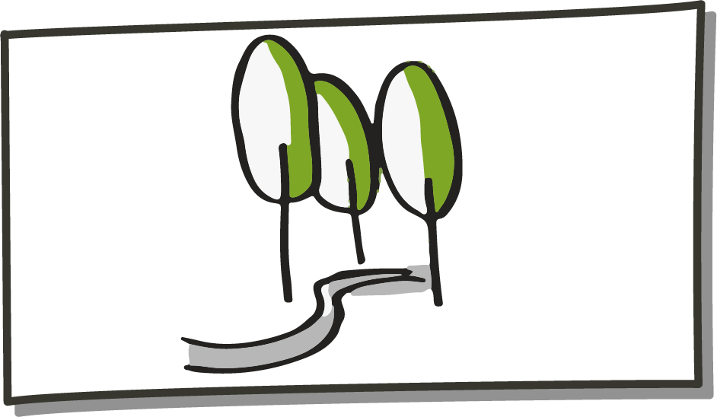
Fundamental to making communities inclusive, is being able to connect with nature and other people in place. Having the opportunities to develop and keep these connections was a strong consistent theme.
Connectedness with Nature
Connections to nature was seen to help develop a deeper connection with place, people, as well as nourishing and beneficial to oneself.
Everyday acts, like smelling flowers, birdwatching, listening to the ocean, being present with wildlife provided an array of sensory experiences, but also importantly - a sense of life – aliveness.
“…that you get at the ocean and those auditory components are also an important element of why you need this birdlife and other aliveness as part of any natural area, so a park and things. Probably the botanical gardens is one of my favourite places to be.” Older person
“A key part of why someone wants to live in a community is to have nice places to be and that will also be alive, so there will be an abundance of wildlife and insects and different plants and flowers, and it'll be nice. That comes back to being fun and happy and friendly and welcoming environment.” Disabled Person
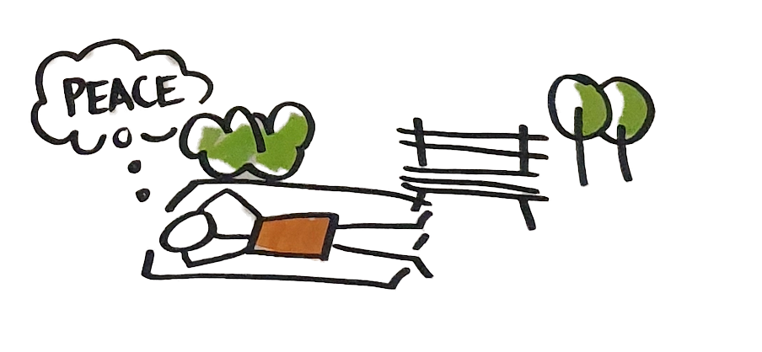
In new and renewal urban development projects, not only does this means that it is essential to safeguard existing access to nature (beach, bush, & biodiversity), but also ensuring improved accessibility to nature in all new urban developments and public space projects. This is achieved by combining inclusive / universal design and designing for our human affinity to nature and ecosystem – known as biophilic design.
The use of trees, plants in urban environments (urban greening) and biophilic design is considered invaluable for individual and community wellbeing now and in the future.
“I was thinking of biophilic design is a community – encourages more connection and it encourages more of a healing, and it’s just a more – [it’s about a better feel] to life, I think. Seen some really good examples … where they’re designing hospitals actually built by local – with local resources, both materials and people, and they’re well connected to that hospital and the hospital just looks like this beautiful resort. It actually looks like a place for giving. I think having that sort of idea distilled into the community, just generally would be really good.” LG worker
“For me, I'm very connected to nature and I've read a lot of scientific evidence as to why nature is so important, and we need open green spaces as part of the environment/the world that we live in. There's just endless benefits to that and I think that's often overlooked by developers and planners and people that want to make money.” Disabled person
Connections to people outside the home and outside of buildings is facilitated through access to nature and moving about streets and the wider community.
We heard this could be facillitated or hindered through the presence and quality of infrastructure and spaces such as footpaths, public spaces, community green spaces and activitycentre/main streets.
“Green spaces – lots of green spaces, please – we all like nature, we all like walking in the park, so lots of community green spaces. “Older disabled person

- Vibrant Places and Experiences
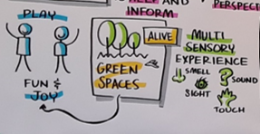
A marker of an inclusive community is the vibrancy conveyed in spaces and infrastructure. Such vibrancy engenders a sense of fun and friendliness, bringing people together, being creative, while ensuring seamless connectivity, and participation.
“An inclusive community brings that sense of fun, and it encourages people to be happy and to be friendly and I'm a big advocate that I think we need more playing by adults as well” Community member
Vibrant places support the flourishing of people through evoking joy, but importantly breaking down silos – helping bringing people together.
“Areas where I feel like people can just come and be and you see people from diverse communities and different cultures. Parks, most of them are all accessible for people, you can come and play, sitting on the grass and you see all the families, sharing food and it's a happy - amongst nature in the sunshine, it's a happy place. Playgrounds. A big one for me is the beach. Yeah, wanting that to be accessible for everyone because I know sometimes not everyone can experience the beach in the same way as everyone else.” – Disabled Person
How spaces are envisaged, used, and regulated played a role in how vibrancy could be encouraged and/or strengthened. How we prioritise certain uses of space plays a role – people spaces, or car spaces. Spaces that are more people places, provide freedom for wandering and interactions – evoke vibrancy.
“That's kind of why we look at markets and I think that's a great example of what we're talking about with movement and place. We can have Salamanca being a movement area during the week -with a lot of cars parked there, just being a bit messy, congested I suppose - then on the weekends it can be a people place. A lot of markets and people wandering around and a lot of interactions. So, you can have multipurpose spaces, I suppose, but imagine if we could have a market every day of the week…that would be a completely different vibe. “ LG worker
Contributing to community life engendered a sense of connection and being part of “something bigger” than themselves. Participants importantly identified that sharing, creativity and spaces that brought people together was a key to making cities and communities inclusive.
“sharing things like culture and arts and being creative and coming together to celebrate…living in that moment and enjoying what’s there”. Disabled person
“Music. I play music, I love music, all sorts of music. Music is a universal language whatever language you speak and it doesn’t have to be classical music; it can be jazz, rock, country, whatever you like. I think a community should always have a place where music and not only music but theatre, can be performed and at present… we do need a music centre. An arts centre. The arts is very important.” Older person
Integral is the need for a network of places and connections between them, that engender togetherness. Such places can be social or contemplative, but they share a depth of experience and grounding that is vital to quality of life.
“So, belonging, embracing others and sharing, so sharing things like culture and arts and being creative and coming together to celebrate those whether it's in a festival or a market or a concert, a play or a show or people coming together to share in that experience, no matter who you are or where you're from or your beliefs.” Parent of a person with disability
“I think for us, we do continually underestimate how art and creativity, whether it is an open space, public space, private, education, schools or health or whatever it might be. I think we ought to pay a little bit more attention I suppose to what that creativity can bring to inclusion, can bring to making the others and communities feel welcome and included more to the point.” Parent of person with disability /LG worker
Participants commonly described how inclusion and participation was curtailed by lack of vibrant place. There were a number of discussions about the greyness - dullness- concrete same looking public spaces, streets, buildings - that lacked life and place.
“Or just plants and trees and colour. Like, why are the pavers grey and why are the structures grey.?” LG worker
“revitalising the heart of X. Because [main] Street is dead.” Disabled Person
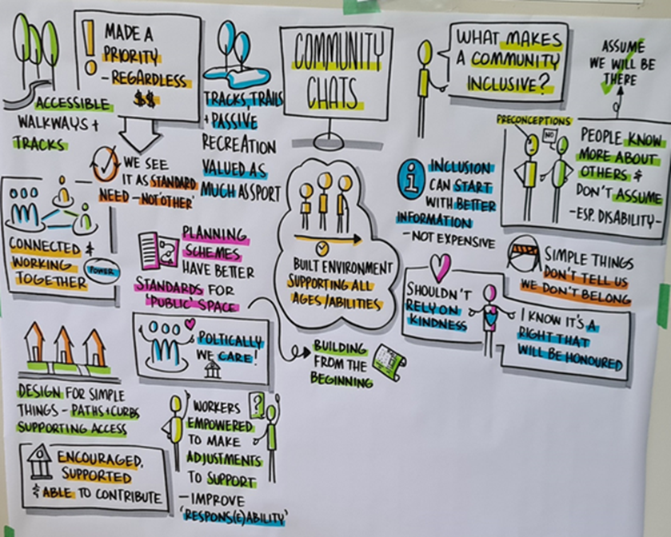
Figure 5. One of the drawings from community what about the question what makes a community inclusive?

What’s Stopping Communities Being Inclusive
The term “community” implies a sense of being brought together, often in place. Yet the lived realities of many people with mind-body diversity across ages, gender and cultures illustrate that “communities” can be anything but inclusive. They can be spaces of exclusion, isolation, sadness and emptiness that lack atmosphere and engender alienation.
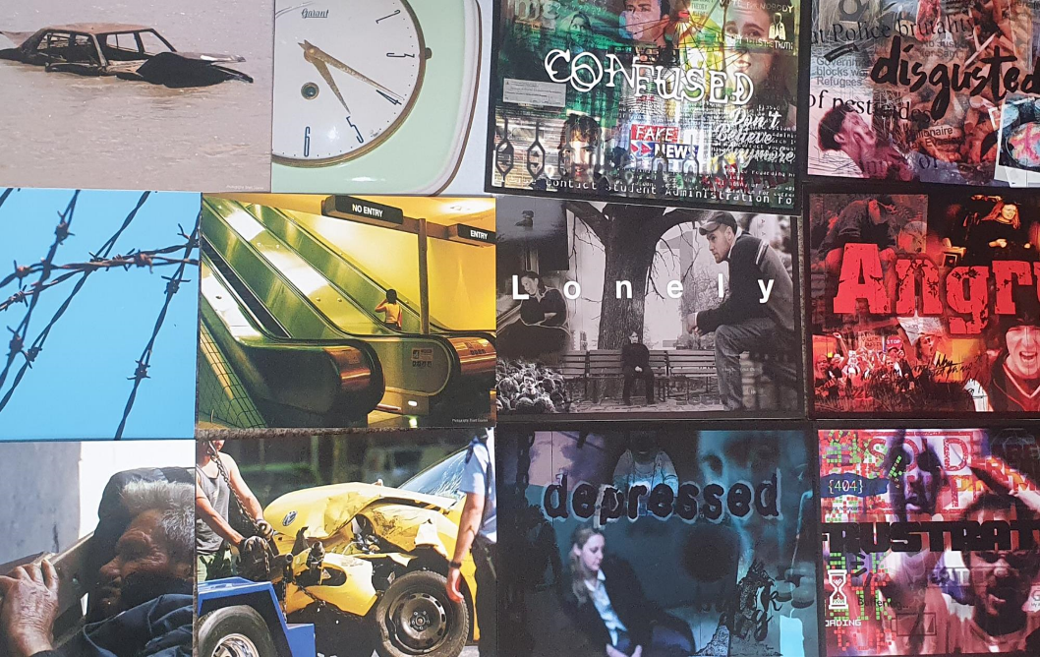
Figure 6: Various cards used by participants to share and express barriers to inclusive communties and cities (Cards Sets Used: Big Picture Cards and Refelxions St Luke’s Resources)
“Lonely was one that I picked because even in busy communities like X, there’s still a lot of lonely older people”. Participant
“Because,... as a.. disabled person we...we feel like- what I feel is not really ahh feel... I feel less... valued. The towns getting better in X, but still a little way to go.” Disabled person
Community can thus be the site of exclusion, which happens systematically and is lived at the level of everyday experience.
When exploring what lead to these experiences, the following core barriers where identified:
- Negative Attitudes Towards Difference.
- Disability is viewed negatively as a cost, burden or bother.
- Limited body-mind diversity considered in policy and planning decision making.
- Public consultations omit or token-include diverse voices, denying agency and exacerbating exclusionary design.
- Working in isolation and silos.
- Accessibility and inclusion are not included from the start, and often seen from the view of compliance with minimum standards.
- Lack of investment in core assets of community - infrastructure, services and spaces important to participation and inclusion – like active and public transport, secure housing, open spaces or local food production.
- Growing social-economic-geographical inequality like housing insecurity, transport disadvantage and cost of living pressure.
- Many members in community feel excluded and isolated, which engenders disengagement.
- Loneliness and poor mental health made worse by inaccessible, dull and difficult to navigate public space, services, and support structures.
“many people with disabilities or chronic illness never feel included. There is always things being made for able bodies but nothing gets done for others. “ Disabled young person
“I might be just repeating myself a bit there - but if you're going to be truly inclusive, people like myself, people with disabilities shouldn't have to justify or argue for a service.” Disabled person

In practice tensions
We heard some specific obstacles remain in urban planning and design process and practiced including entrenched ways of working and culture that continue to perpetuate exclusionary environments.
Working in Isolation
Participants, particularly those in government roles and built environment roles, frequently referred to isolated and isolating work patterns and structures as ingrained in organisations. These siloed and isolated structures and ways of working engender a sense of isolation, futility and mistrust in institutions.
The siloed structures of government create a sense of distance between governance and community, as well as an unwillingness to work together to address the increasingly complex challenges that influence planning and urban environments. They also create a sense that people are not heard, further precipitating a lack of belonging and growth in social isolation.
“…sometimes it can get quite lonely when you're trying to listen, share power, work together and staying power because some people just don't want to do that.[Laughs] So, that's why I chose lonely. Then I chose this card (Mask), and for me that kind of represents how people don't work together… …and often it's about masking who they really are, their organisation that they come from, everything is all dolled up and pretty……but it's not real because you……can't see the person behind the mask or the people behind the mask.” LG Worker
What was also raised by participants, those working or interacting with urban governance processes, is the power hierarchies that exist founded on colonist and ableist ideas. These power hierarchies and top-down dominance of working suppress human rights and stifled sustained change in equity and access being achieved.
“Colonisation and we keep it colonised because even in X, I mean, I’ve only been there a month but I’m just sort of looking at the hierarchies and going, this is bullshit.” Community member
Even when working locally, the emphasis was less on documented evidence need and good practice, but the political cycle which influenced the senior managerial decision making and willingness to make change.
“…transport is a big issue on the city deal table. Let's get a commitment from the bloody city deal people. Let's make those mayors and general managers work for what they're doing in a regional aspect, as we are working locally with our residents on issues of transport, not just within inclusivity but for all ages, all abilities. We're trying, we are collaborating with people on the ground, but they're not taking that information to their city deal meeting.” LG worker
Limitations of Compliance-based Thinking
Often in planning, design and service delivery, inclusion is seen as a set of legislative requirements that must be met. These minimum standards (such as building and engineering codes) may have good intentions but they turn access into a tick-box exercise, a going-through-the-motions process that is separated from the realities of community life and good planning practices.
“Not many engineers take into account planning principles - it's just standards and that sort of stuff - so that's why we get pretty plain, grey environments out there. So, we're trying to mix it up a bit this year. We’ll see. I think we've been somewhat successful, but we'll keep going. “ LG worker
Reducing inclusion to a matter of compliance neglects the fact that people’s needs, and abilities change throughout life. Such thinking strips planning of its potential to be truly responsive to community needs.
“But if we don’t actually check in with the people, the end-users, then maybe we haven’t got it completely right and practical. So it might be to standard, but it might not necessarily be practical in the way that we use that or access that. “ LG worker
Another effect of limiting compliance-based thinking is furthering exclusion, as well as missing opportunities to better plan and design more sustainable inclusive and integrated cities and communities = SDG Goal 11.
The findings suggest move from compliance-based thinking is necessary to create more equitable and alive cities and communities for all people.
This can be facilitated by Universal /inclusive Design principles that set broad parameters, rather than minimum standards, for the design of movement, spaces and infrastructure that key to engendering inclusive cities and communities.
“Universal design principles, of which there are seven or eight (matter) but being flexible, being simple in the design (is critical). I think we need to move away from a compliance model.” Disabled Person
Accessibility is Perceived as Cost burden
Link to compliance thinking, is this more generalised misperception about disability – in terms what is disability, and the cost-burden associated with provision of accessibility.
“The other thing, in addition to resources though is there’s still a misconception that inclusion requires significant infrastructure cost and I think small business, big business, there’s still a real lack of understanding that inclusion is often just - can start, can be really effective, just by providing information. So yeah, there’s - the - I mean, any business person is obliged by legislation to provide a level of access but legislation doesn’t meet usability, often times.” Disabled person
“yeah, they just don’t meet a cross-section of disability. There’s a real misconception that disability is really limited to one certain type of disability. I think there’s still mystique and sense that people with certain disabilities are so different that they shouldn’t be included or that they wouldn’t want to be included. Right? So there’s a level of - there’s still a level of this almost shock and surprise. Really? You have an adult child that might want - you’re an adult’s child that you are still - that you’re looking after that might need to have a change room facility, right? It’s still like, what? There’s still a level of just lack of knowledge. Just really lack of knowledge.” Parent with a person with a disability
“As we move forward, right now it seems that we’re at this point that there is still this cost issue where people just say okay, we can’t do that but more and more - I mean, my hope is that actually [laughs] we wouldn’t say we’re not going to build the hospital and we wouldn’t say we’re not going to fix the pot holes in the middle of Davey Street, you just have to be done and there’s trucks that use those roads. We’re not saying, well okay, no more trucks, right? We do it because we have to do it and so my hope is that accessibility will become the same thing.” LG worker
There was also felt that cost-burden was linked to seeing disability as other. This was experienced as direct avoidance to providing access.
“some developments they'll spend more money on avoiding putting access into a building than it would cost them to put the thing in the first place. That’s straight across the board on a lot of – they’ll avoid putting it in so they can save. But in the end, it ends up costing them more.” Disabled person
People discussed the reality that body-mind diversity and equity is just not thought about in everyday practice nor broader community. Disabled people needs are seen as add on not essential and central.
“It’s not at the centre – it kind of sometimes feels like it’s the add-on or the extra thing to think about, rather than being one of those key – and that’s just not about like actual planning, that’s just you know it feels like because we’re at council, we’re talking about council. But that’s just across the community in general.” Disabled person
Also, because of how planning and governments operates, in fragmented – lacking an integrated - approach, what happens is that core planning focuses are put against each other - equity and accessibility (spatial justice) vs environmental justice. This is instead of an integrated all-inclusive sustainable planning approach where universal design, urban greening, smart growth, and planning for country are considered together.
“Yeah, I’d been thinking about that, when you were talking about the Building Code, that you’re competing for airspace a bit aren’t you, in this. Because you might be competing with environmental issues for instance, or you know asbestos, solar power, or something like that. So the people who are dealing with the Building Code, or maybe planning – the Planning Rules, might be skewed a bit more towards maybe kind of other issues, and environmental might be one.” LG worker
While these in-practice tensions currently hindered inclusive approach to planning and designing cities and communities - the participants also understood them as the point of change– the change that was needed and possible.

Embedding Equity and Inclusion - The key areas where change is needed.
To create communities and cities that engender the five felt elements of what makes communities inclusive requires significant change in mindset and approach.
One key mindset shift is that the attributes that engender inclusive communities and cities must be understood and valued as core assets.
Planning for inclusion involves enduring investment in the social, in shared prosperity in the health and wellbeing of people and place that is recouped in a more connected, thriving, and cohesive community.
As the current experience of communities and cities are far from inclusive, the research identified three areas where change is needed: 1. Inclusive Urban Planning and Design Practice, 2. Inclusive Urban Governance – Processes and decision making, 3. Education and Leadership.
Each area is outlined below - these are not fixed or exhaustive but reflective of what participants commonly conveyed.
01 Inclusive Urban Planning and Design Practice:
- All people must be at the centre of what we do and be involved from the start.
- Inclusive/universal design with biophilic design /urban greening is integral to communities.
- Foregrounding equity, ease and accessibility in planning and designing for movement and place.
- Raising ambitions by going beyond minimal or compliance-focused approach.
- Develop inclusive planning practice guidance and urban design codes.
- Integrated planning that centres equity and inclusion, wellbeing, climate adaptation.
- Future proofing design using inclusive sustainable approach.
“Sustainability, so making sure when we build stuff or plan stuff, … we need to think about how long the ..asset is going to last for and build for the end of that asset life instead of designing for today's standards which will be out of date in five years' time and then we're all in a bit of a mess. So, if a building is going to last for 50 years, build for how you think it's going to be in 50 years' time, and you'll probably be right. Same with a road; how do you want people to use the road? Do you want people to drive up there for the next 50 years? If you want that you can build a three lane highway but if you want people to wander around and have a good space in 50 years' time, design for that and the people will come.” LG Worker
“I think it’s being also brave enough, whether it’s brave enough or able to go forward with ideas that aren’t fully developed. We’re very much, as a council, we’re very risk-averse, so everything has to be kind of tidy or boxed before it’s presented. In this model, it’s like this is what we’re thinking and going early, if you haven’t got design plans, just so you know that that thinking is in there, so maybe a little bit a less– risk-averse I think, is part of that too.” LG worker
02 Inclusive Urban Governance – Processes and decision making
- Lived expertise is valuable knowledge and embedded in all aspects of urban governance.
- Working in collaboration and co-creating, working across disciplines, sectors, and agencies.
- Communicate with all from the start using multiple methods suitable for diverse audiences.
- Decision making has integrity, flexibility, and be guided by lived knowledges.
- Integrated planning processes for more equitable, connected and efficient ways of working.
- We listen, learn and then act.
“So that one about you kind of get into a way of doing something, it’s kind of the way that we’ve done it, and it’s like in any organisation, that’s the same thing. But then how do we change that? How do we make sure [that we’re, asking community about what is important for them? How can council hear the voice of the people within community and then make those changes, whether it’s around process, or around planning, or the way that we engage.” LG worker

“Broadly, more inclusive community input into changes in the community that go beyond traditional governance.” Disabled person
“As an organisation, it needs to have those relationships that you feel free. Like you know both [X] and me, we’ve worked together on different things, and we could speak quite openly and freely and any time whether it’s over the phone, in an email or in person. Being able to have those relationships across this organisation would make those engagements more efficient, and you’d feel desire to do that. Rather than if I – we haven’t met before, but if I didn’t know you, which I don’t, [laughs], I’d be less inclined to go over and say oh, what do you think about this. So I think it’s building those relationships so that we can…Yeah, trust, yeah.” LG Worker
The opportunity to share in and co-create places of connectedness, joy and all-welcoming is critical in promoting an inclusive community.
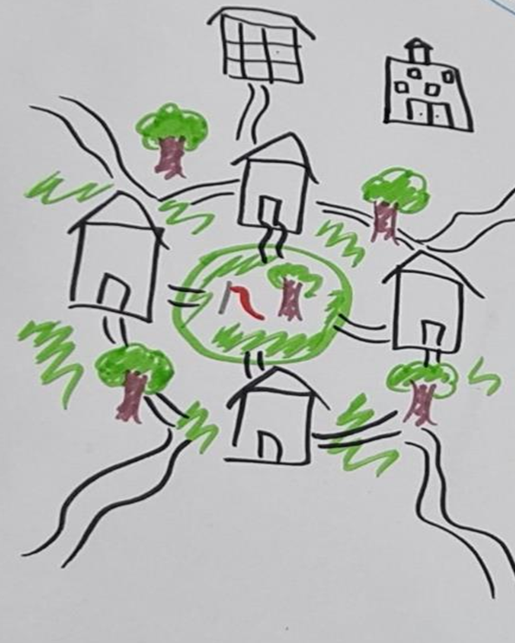
Figure 7. Participants drawing - Connectedness with homes, continuous paths, public spaces and nature integral to fostering inclusive community.
03. Education and Leadership
- Recognise and understand planning for our human diversity across the lifespan.
- Challenge negative perceptions and naysayers.
- Awareness raising education and amplifying diverse voices.
- Demonstrate what’s possible using case studies while respecting the unique context of place.
- Being inclusive creates economic and regional development.
- Representation and leadership by and with disabled people is essential.
“So I feel like education is really important. Being able to educate people to create that understanding for not just people living with a disability, but people living, like you said, with mental illness and other chronic diseases. I feel like understanding and education is really important. You can't grow any sort of respect or understanding without being educated and informed. “ -Young person
“They constantly - I mean, they should - the constant message is, we need to train our leadership and our higher management because they set the tone and if they don’t accept things, nothing else will happen further down.” LG Workers
“I suppose I'm at the point of, I don't want people to walk out of the room going, oh isn't that warm and fuzzy and a nice idea. I want people to start going, let's do something.” Disabled person
Figure 8. Photograph of a graphic harvest from a community chat showing key barriers and changed needed to make more inclusive communities.
Planning Inclusive Communites: Graphic summary of the core elements and change needed to make communites and cities inclusive
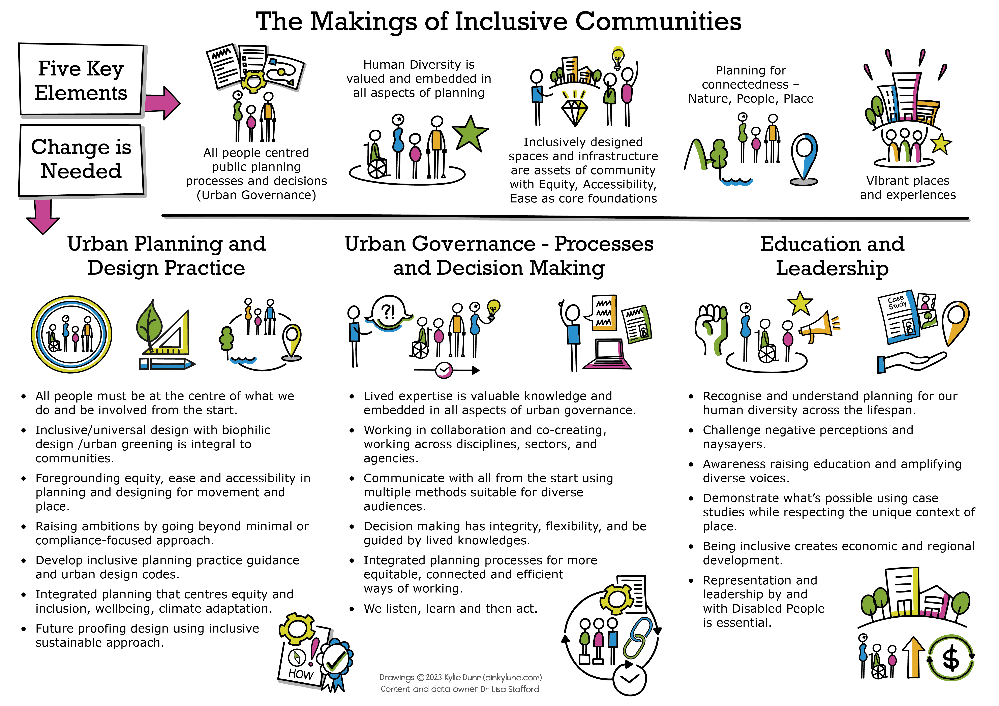

What’s Next?
This research establishes that an inclusive community is where all people feel valued and respected, belong, have unrestricted opportunities to move about and participate in everyday life, and exercise choice in how they live their lives, and are continually involved in decision making and planning processes to enrich community life.
What is also clear from the research findings is that inclusive communities and cities are shaped by the processes and outcomes of urban planning and design and broader society.
These insights help provide the scope for the change needed in urban planning practice and urban governance. Centring inclusion and equity at the heart of urban planning is key, but equally important are our:
- Ways of Working
- Assets of Community
- Agents of Change - Champions
Our next stage - stage 2 – involves exploring the changes needed identified from stage 1a&B, directly with urban planning practitioners and disabled people to co-create practice-based model, education resources and practice tools on how to plan inclusively. The aim being to have an applied inclusive approach to planning our cities and communities that will benefit all bodies and minds, while upholding rights and environmental and social justice.

References
Australian Bureau of Statistics. (2019, October 24). Disability, Ageing and Carers, Australia: Summary of Findings. Australian Bureau of Statistics https://www.abs.gov.au/statistics/health/disability/disability-ageing-and-carers-australia-summary-findings/latest-release
— (2021). Census, ABS Website, accessed 12 January 2023. https://www.abs.gov.au/statistics/health/health-conditions-and-risks/health-census/2021#cite-window1
Australian Institute of Health and Welfare (2022) People with disability in Australia 2022, catalogue number DIS 72, AIHW, Australian Government.
Azzopardi, A., & Grech, S. (Eds.). (2012). Inclusive communities: A critical reader (Vol. 16). Springer Science & Business Media.
Bailey, K., Lobenstine, L., & Nagel, K. (2012). Spatial justice: A frame for reclaiming our right to be, thrive, express and connect. The Design Studio for Social Intervention with the Generous Support of the Praxis Project, 1-21.
Baldwin, C., & Stafford, L. (2019). The Role of Social Infrastructure in Achieving Inclusive Liveable Communities: Voices from Regional Australia. Planning Practice & Research, 34(1), 18-46. https://doi.org/10.1080/02697459.2018.1548217
Bezmez, D. (2013). Urban Citizenship, the Right to the City and Politics of Disability in Istanbul. International Journal of Urban and Regional Research, 37(1), 93-114.
Boys, J. (2014). Doing disability differently: An alternative handbook on architecture, dis/ability and designing for everyday life. Routledge.
Campbell, F. K. (2009). Contours of ableism: the production of disability and abledness. Palgrave Macmillan.
Chouinard, V. (1997). Making space for disabling difference: challenging ableist geographies. Environment and Planning D: Society and Space, 15, 379–387. https://journals.sagepub.com/doi/pdf/10.1068/d150379
Commonwealth of Australia (Department of Social Services) (2021). Australia’s Disability Strategy 2021-2031.
— Outcomes Framework - Australia’s Disability Strategy 2021-2031. https://www.disabilitygateway.gov.au/ads/strategy
Davidoff, P. (1965). Advocacy And Pluralism In Planning. Journal of the American Institute of Planners, 31 (4):331-338. DOI: 10.1080/01944366508978187
Disability rights UK (2015). Inclusive Communities. A research report. https://www.disabilityrightsuk.org/sites/default/files/pdf/3.%20InclusiveCommunitiesResearch.pdf
Dyck, I. 2005. Feminist Geography, the ‘Everyday’, and Local–global Relations: Hidden Spaces of Place-making. The Canadian Geographer / Le Géographe canadien, 49(3): 233–243.
Espino, N. A. (2015). Building the inclusive city: theory and practice for confronting urban segregation. Routledge.
Fainstein, S. S. (2014) The just city, International Journal of Urban Sciences, 18 (1): 1-18, DOI: 10.1080/12265934.2013.834643
Finlay, Linda (2011). Phenomenology for Therapists: Researching the Lived World. J. Wiley.
Friedmann, J. (2010). Place and place-making in cities: A global perspective. Planning Theory & Practice, 11(2), 149-165.
Garland-Thomson, R. (2017). Extraordinary bodies: figuring physical disability in American culture and literature (Twentieth anniversary ed.). Columbia University Press.
Gleeson, B. (2001). Disability and the open city. Urban Studies, 38 (2): 251–265.
Gleeson, B. and Steele, W. (2010). A Climate for Growth: Planning South-East Queensland, St Lucia: University of Queensland Press.
Goodley, D. (2014). Dis/ability studies: Theorising disablism and ableism. Routledge.
Harvey, D. (2008). The Right to the City. New Left Review, 53, 23-40.
Harvey, D. (2009). Social justice and the city (Revised ed.). Athens, GA: University of Georgia Press.
Harpur, P. (2009). Sexism and Racism, Why Not Ableism?: Calling for a Cultural Shift in the Approach to Disability Discrimination. Alternative Law Journal, 34(3), 163–167.
Horton, J., Christensen, P., Kraftl, P., & Hadfield-Hill, S. 2014.‘Walking … Just Walking’: How Children and Young People's Everyday Pedestrian Practices Matter. Social and Cultural Geography 15(1): 4-115.
Hosking, D. L. (2008). Critical Disability Theory. A paper presented at the 4th Biennial Disability Studies Conference at Lancaster University, UK, Sept. 2-4. https://www.lancaster.ac.uk/fass/events/disabilityconference_archive/2008/papers/hosking2008.pdf
Ife, J. (2016). Community development in an uncertain world: Vision, analysis and practice (2nd ed.). Port Melbourne: Cambridge University Press.
Imrie, R. (1996) Ableist geographies, disablist spaces: Towards a reconstruction of Golledge’s Geography and the Disabled. Transactions of the Institute of British Geographers, 21(1): 397–403.
Imrie, R., 2001. Barriered and bounded places and the spatialities of disability. Urban studies, 38 (2), 231–237.
Imrie, R. (2003). Architects’ Conceptions of the Human Body. Environment and Planning D: Society and Space, 21(1), 47–65. https://doi.org/10.1068/d271t
Jacobs, J. (1961). Dark Age Ahead: Author of The Death and Life of Great American Cities. Vintage Canada.
Jampel, C. (2018). Intersections of disability justice, racial justice and environmental justice. Environmental Sociology, 4(1), 122-135.
Mallett, R., & Runswick-Cole, K. (2014). Approaching disability: Critical issues and perspectives. Routledge.
Manzo, L. (2003). Beyond house and haven: toward a revisioning of emotional relationships with places. Journal of Environmental Psychology, 23, 47–61
Marcuse, P. (2015) "Gentrification, social justice and personal ethics." International Journal of Urban and Regional Research, 39.6, 1263-1269.
Meekosha, H. (2011). Decolonising disability: Thinking and acting globally. Disability & Society, 26(6), 667-682.
Meekosha, H. & Shuttleworth, R. (2009) What's so ‘critical’ about critical disability studies? Australian Journal of Human Rights, 15(1), 47-75, DOI: 10.1080/1323238X.2009.11910861
Middleton, J. 2011. ‘I’m on Autopilot, I Just Follow the Route’: Exploring the Habits, Routines, and Decision-making Practices of Everyday Urban Mobilities. Environment and Planning, 43(12): 2857–2877
Moon, N. W., Baker, P. M., Roy, R. G., & Bozzorg, A. (2014). Disability Issues and Planning Education: Findings from a Longitudinal Survey of Planning Programs and Lessons for Urban e-Planning. International Journal of E-Planning Research (IJEPR), 3(3), 38-52. http://doi.org/10.4018/ijepr.2014070103
National People with Disabilities and Carer Council. (2009). Shut Out: The Experience of People with Disabilities and their Families in Australia, Commonwealth of Australia, Canberra.
Ng, M. K. (2022). Planning Standards and Spatial (in) Justice. Planning Theory & Practice, 23(2), 167-172. https://doi.org/10.1080/14649357.2022.2061773
Oliver, M. (2009). Understanding Disability: From theory to practice (2md ed.). New York: Palgrave Macmillan
Pineo, H. (2020). Towards healthy urbanism: inclusive, equitable and sustainable (THRIVES) – an urban design and planning framework from theory to praxis. Cities & Health, 1–19. DOI: 10.1080/23748834.2020.1769527
Relph, E. (1976). Place and placelessness. (Research in Planning and Design) 1st Edition. Sage.
Sanoff, H. (2000). Community Participation Methods in Design and Planning. New York: John, Willey & Sons.
Schatz, L., & Rogers, D. (2016). Participatory, technocratic and neoliberal planning: an untenable planning governance ménage à trois. Australian Planner, 53(1), 37-45.
Seamon, D. (2018). Life Takes Place: Routledge.
— (2013) Place Attachment and Phenomenology: The Synergistic Dynamism of Place. In Lynne C. Manzo & Patrick Devine-Wright, eds., Place Attachment: Advances in Theory, Methods, and Applications, pp. 11-22, NY: Routledge. http://www.routledge.com/books/details/9780415538213/]
Seamon, D., & Sowers, J. (2008). Place and placelessness (1976): Edward Relph. Key Texts in Human Geography, 43–52.
Shevellar, L., Johnson, L., & Lyons, K. (2015). Re-imagining the practices of town, social and community planning in Australia: opportunities for planning in neoliberal policy settings. Australian Planner, 52(4), 266-276.
Sins Invalid. (2015, September 17) 10 Principles Of Disability Justice. Sins Invalid. https://www.sinsinvalid.org/blog/10-principles-of-disability-justice
Soja, E. W. (2009). The city and spatial justice [La ville et la justice spatiale]. Spatial Justice [Justice Spatiale], 5. http://www.jssj.org/wp-content/uploads/2012/12/JSSJ1-1en4.pdf
Soja, E. W. (2010). Seeking spatial justice. University of Minnesota Press.
Stafford, Lisa (2014) The journey of becoming involved in urban spaces by children with diverse mobility. In Buccieri, K (Ed.) Body tensions: Beyond corporeality in time and space. Inter-Disciplinary Press, United Kingdom, pp. 97-120. https://eprints.qut.edu.au/76201/
Stafford, Lisa & Baldwin, Claudia (2015) Planning neighbourhoods for all ages and abilities: A multi-generational perspective. In Burton, P & Shearer, H (Eds.) State of Australian Cities Conference 2015: Refereed Proceedings. State of Australian Cities Research Network, Australia, pp. 1-16. https://eprints.qut.edu.au/93600/
Stafford, L., & Baldwin, C. (2018). Planning Walkable Neighborhoods: Are We Overlooking Diversity in Abilities and Ages? Journal of Planning Literature, 33(1), 17–30. https://doi.org/10.1177/0885412217704649
Stafford, L & Volz, K. (2016) Diverse bodies-space politics: towards a critique of social (in)justice of built environments. TEXT: Journal of Writing and Writing Programs, 34(Special Issue), pp. 1-17.
Stafford, L. (2020). Planning Inclusively: Disrupting ‘Ableism’ to Make Communities Just for All. Centre for Justice, Briefing Note series, 10. ISSN 2652-5828 (Print), 2652-6441 (Online)https://research.qut.edu.au/centre-for-justice/wp-content/uploads/sites/304/2021/02/Briefing-paper-series-Dec-2020-Issue10.pdf
Stafford, Lisa, Adkins, Barbara, & Franz, Jill (2020) Bounded at the driveway's edge: body-space tensions encountered by children with mobility impairments in moving about the neighbourhood street. Children's Geographies, 18(3), pp. 298-311.
Stafford, L. (2022). Planners, we need to talk about Ableism. Disability Justice and Urban Planning, Planning Theory & Practice, 23:1, pp. 106-111.
Stafford, L., Vanik, L. & Bates, L. K. (2022) Disability Justice and Urban Planning Edition, Planning Theory & Practice, 23:1, 101-142, DOI: 10.1080/14649357.2022.2035545
Terashima M and Clark K (2021). The Precarious Absence of Disability Perspectives in Planning Research. Urban Planning 6(1): 120–132. DOI: 10.17645/up.v6i1.3612
Thompson, S. (2012). Planning for diverse communities. In S. Thompson & P. Maginn (Eds.), Planning Australia: An overview of urban and regional planning (2nd ed., pp. 226–253). Cambridge University Press.
UN DESA. (2007). Final Report of the Expert Group Meeting on Creating an Inclusive Society: Practical Strategies to Promote Social Integration. 10 – 13 September, Paris.
United Nations, Habitat III. (2016). The Right to the city and cities for all. Available at: http://habitat3.org/wp-content/uploads/Policy-Paper-1-English.pdf
— Sustainable Development Goals. https://sdgs.un.org/goals
— (adopted 2006). Convention on the Rights of Persons with Disabilities (CRPD).https://www.un.org/development/desa/disabilities/convention-on-the-rights-of-persons-with-disabilities.html
Vavik, T., & Keitsch, M. M. (2010). Exploring relationships between universal design and social sustainable development: some methodological aspects to the debate on the sciences of sustainability. Sustainable development, 18(5), 295-305.
Wiesel, I., Whitzman, C., Bigby, C. & Gleeson, B. (2017). ‘How will the NDIS change Australian cities?’, MSSI Issues Paper No. 9, Melbourne Sustainable Society Institute, The University of Melbourne.
Weisman, L. K. (1992). Discrimination by design: A feminist critique of the man-made environment. Urbana: University of Illinois Press.
Whitzman, C; Legacy, C; Andrew, C; Klodawsky, F; Shaw, M; Kalpana, V (2015), Building Inclusive Cities: Women’s Safety and the Right to the City, Routledge, London.
Wolbring, G. (2008). The politics of ableism. Development, 51, 252–258. https://doi.org/10.1057/dev.2008.17

